MSZ30

电气使用说明书 -昆仑屏
ELECTRIC CONTROL SYSTEM
USER MANUAL -KUNLUN

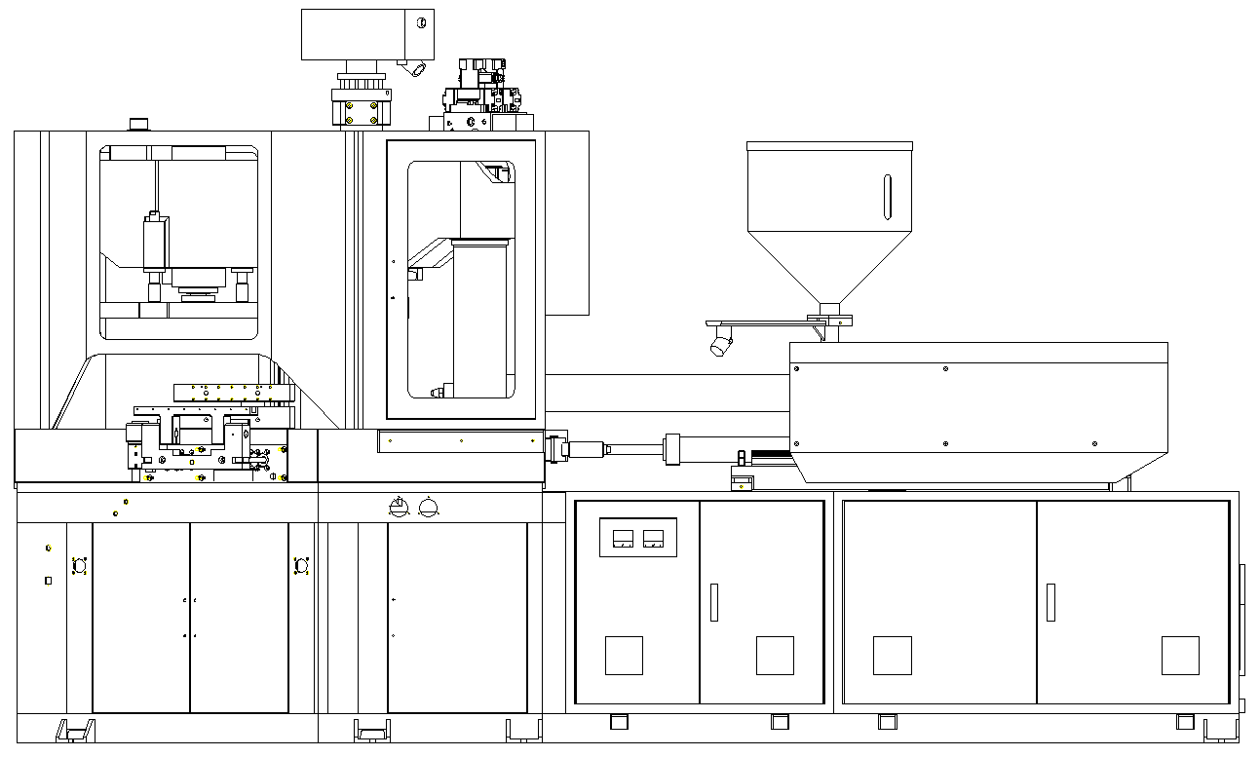

江苏维达机械有限公司
JIANGSU VICTOR MACHINERY CO., LTD
Table of contents目录
一、 Summary概述 3
二、 Control system description控制系统描述 4
2.1 The main interface主界面 4
2.2 Monitoring operation set操作监控画面 5
2.3 Temperature set温度设定 16
2.4 Temperature PID preferences温度PID参数设定 17
2.5 Pressure and flow settings压力流量设定画面 18
2.6 Linear scale set电子尺设定画面 19
2.7 Alarm recording报警信息记录 23
2.8 Machinery preferences机械参数设定 24
2.9 Action time monitor动作时间监视 27
2.10 Input monitor输入监视 28
2.11 Output monitor输出监视 29
2.12 Parameter access参数存取画面 30
2.13 Cycle curve周期曲线 32
2.14 Statistics数据统计 33
三、 Operation运行 34
3.1 Manual operation手动操作 34
3.2 Semi-auto operation半自动运行 39
3.3 Auto operation自动运行 40
四、 Special configuration instructions特殊配置说明 40

- Summary概述
This system use Omron CPIH series PLC as the core of the control system.Touch screen use Omron 15.6" colour touch screen.The whole system is easy to operate, accurate control and reliable action with Full communication connection.
本控制系统使用欧姆龙 CP1H 系列PLC 作为控制系统核心。操作界面采用15.6寸彩色触摸屏,整个系统采用全通讯连接,具有操作方便,控制准确,动作可靠的特点。

- Control system description控制系统描述
- The main interface主界面
The welcome screen, as follow:
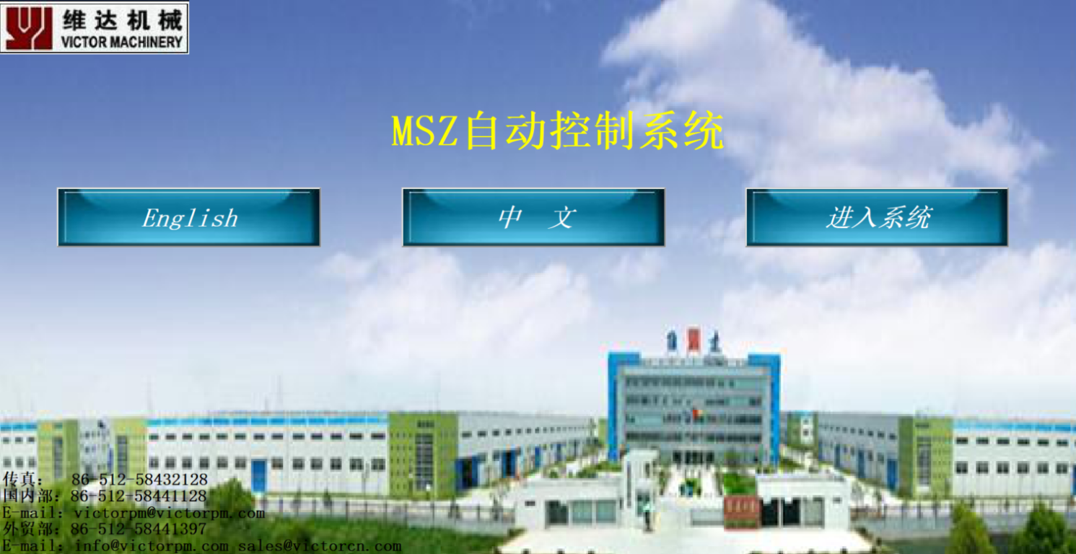
欢迎画面，如下图：

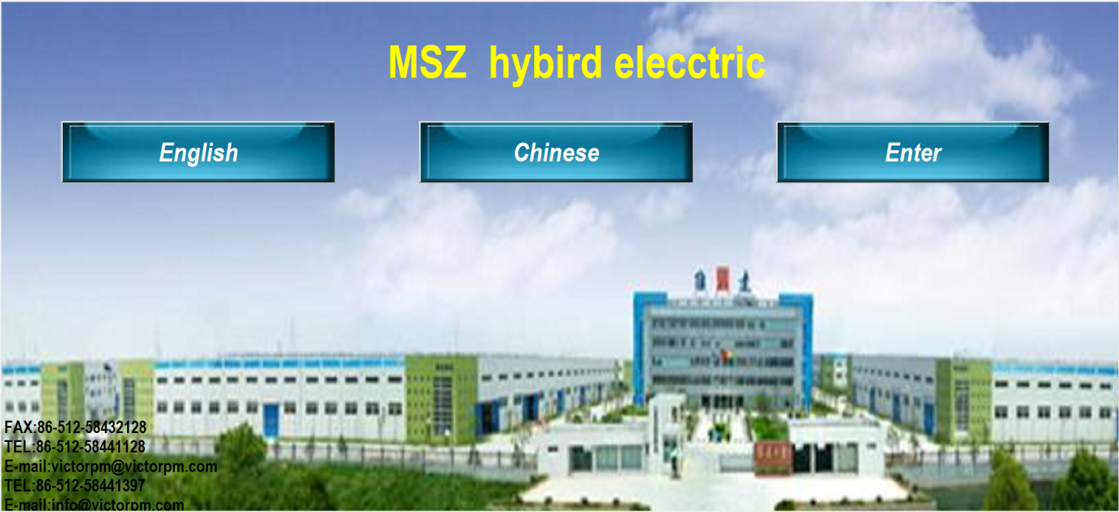

Into the system screen进入系统画面
Chose Chinese or English language选择中文或英文语言
Below is contact way,if you have any questions, please feel free to contact us on the website or by phone
在下面是联系方式,有任何疑问可以随时登陆网站或者电话联系
- Monitoring operation set操作监控画面
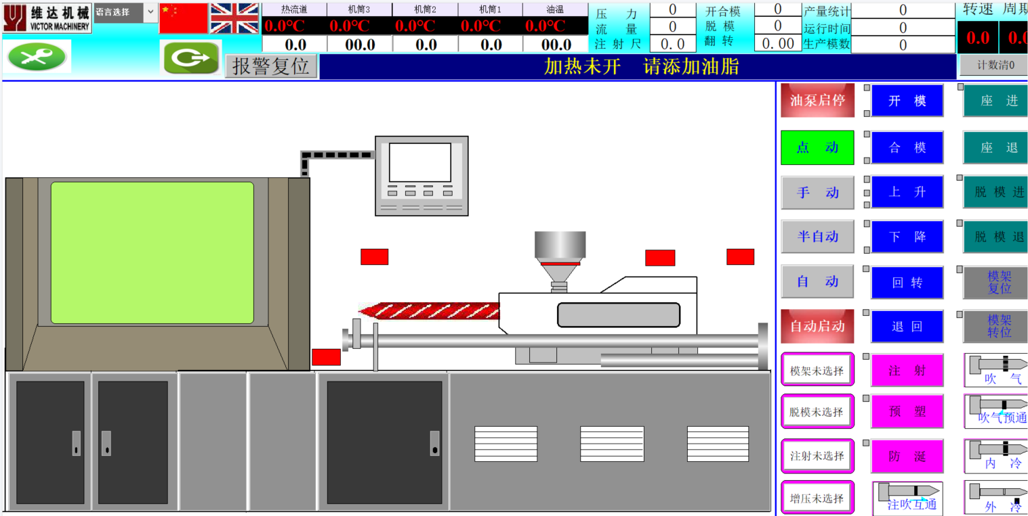
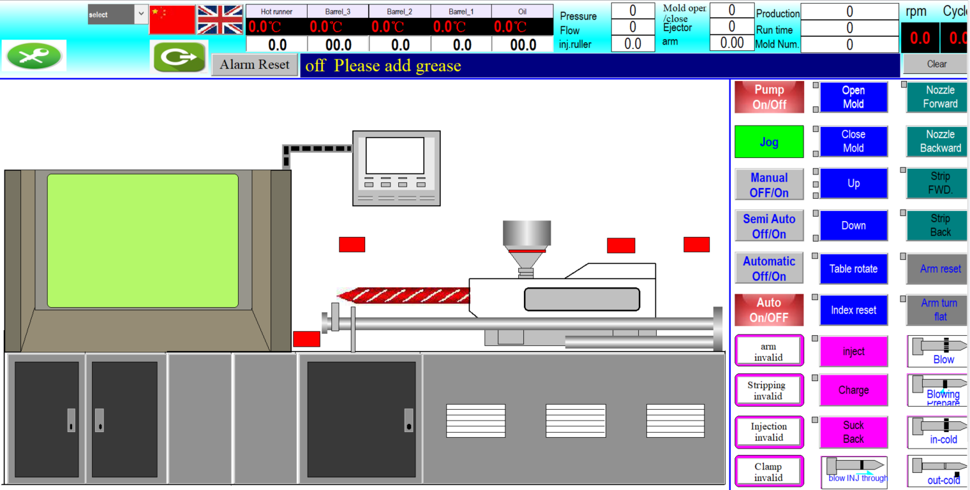

- Temperature display area only shows data, can not be operated.
温度显示区域这部分只可以显示，不可以操作。
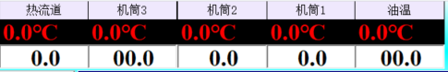
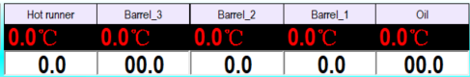

- Alarm Display area
报警显示部分
When there is a fault, the fault information will be timely reminded,
touch 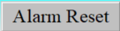 to reset and remove alarm.
当有故障时故障信息会有及时的提醒，触摸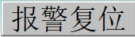 复位消除报警
- Real-time pressure and flow monitoring
实时压力和流量监控
- Product count and reset
产品计数与清零
- Mold shot counter
模数统计
- Cycle time and screw speed monitoring
周期和螺杆转速监控
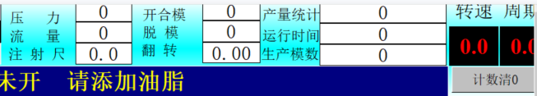
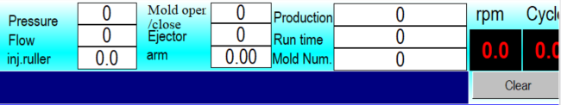
- Operation area
操作区
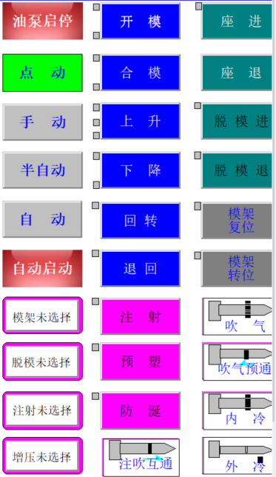

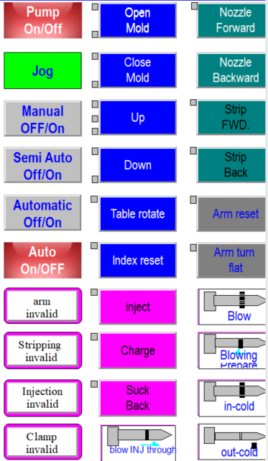

注射选择  Injection OFF/ON | 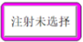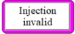 | Injection switch ON,machine can do action of material injection,pre-plasticizing  (screw charge), suck back, otherwise cannot.  触摸该开关则有注射预塑防涎动作，反之则无  NOTE:When injection ON,only waiting temperature reach setting,then can do action of pre-plasticizing(screw charge)and suck back.  注意：选择此开关时，预塑防涎必须等到温度都到后才有相应的动作
脱模选择  Stripping OFF/ON | 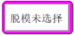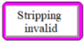 | This switch control whether do stripping action, generally used for manual operation.  触摸该开关选择是否有脱模动作，一般用于手动
模架选择  Turn arm OFF/ON | 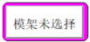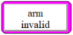 | This switch control whether do stripper frame action, generally used for manual operation.  触摸该开关选择是否有模架动作，一般用于手动
增压选择  Press increase OFF | 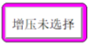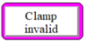 | This switch control whether do pressurization action, generally used for manual operation,can check the change of pressure when mold closing.  触摸该开关选择是否有增压动作，一般用于手动，在合模时可以看出压力的变化
点动  Jop | 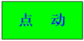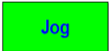 | Touch the switch to enter the moving state, which corresponds to the correct position of the hydraulic valve light  触摸该开关选择进入点动状态，用来对应液压阀灯位置是否正确
手动  Manual | 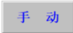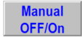 | Touch the switch to select manual mode, only in this mode can start the pump  触摸该开关选择进入手动状态，只有在此模式下才可以启动油泵
半自动  Semi-automatic | 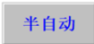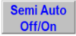 | Touch the switch to select semi-auto mode, machine will stop after one cycle action finish  触摸该开关选择进入半自动状态,设备做完一个周期后就停止在开始位置
自动  Automatic | 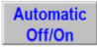 | Touch the switch to select automatic mode  触摸该开关选择进入自动状态
自动启动  Automatic startup | 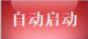 | Touch the switch and machine will keep running until this switch is touched again and machine will stop running when it returns to the original position  触摸该按钮设备连续运转，直至再次触摸，设备回到初始位置停止运转  It works under automatic or semi-automatic，the following conditions must be met:  Stripper backward in place,table up in place,mold opening in place.when machine start running,mold should be close then open,stripper should be forward then backward.  在自动或者半自动时有效，须满足以下条件：脱模退到位转台上升到位，开模到位，开始操作时需要先合模，再开模，先脱进再脱返
油泵起停  Oil pump start stop | 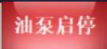 | Start - stop switch of oil pump motor, start must be manual mode  油泵电机的起停开关，启动必须是手动模式
座退  Nozzle backward | 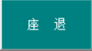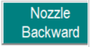 | Touch the button, injection unit move backward till arrive the back limit switch  触摸该按钮，射台后移，到后限位开关后停止
座进  Nozzle forward | 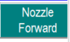 | Touch the button, injection unit move forward till arrive the front limit switch触摸该按钮，射台后移，到前限位开关后停止
脱模进  Stripper forward | 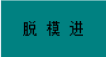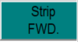 | Touch the button, stripper move forward till arrive the limit switch  触摸该按钮，脱模延伸出去，到进限位开关后停止
脱模退  Stripper backward | 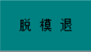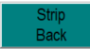 | Touch the button, stripper move backward till arrive the limit switch  触摸该按钮，脱模缩回去，到返回限位开关后停止
注射  Injection | 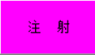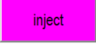 | Touch the button to do material injection till reach the position of injection 2.  触摸该按钮，开始注射，到达注射2后停止
预塑  Screw charge | 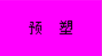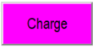 | Touch the button to start pre-plastic, screw reversal to reach the pre - plastic position then stop  触摸该按钮，开始预塑，螺杆反转到达预塑位置后停止  It should be noted that only reach setting temperature can do this action  需注意温度到才可以执行此动作
防涎  Suck back | 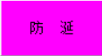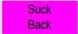 | Touch the button to start suck-back, screw reversal to reach the suck-back position then stop,note that only reach setting temperature can do this action  触摸该按钮，开始防涎，螺杆反转到达防涎位置后停止, 需注意温度到才可以执行此动作
开模  Open mold | 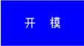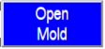 | Touch this button, injection and blow molds open.  触摸此按钮，注吹模开模
合模  Close mold | 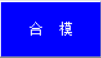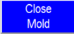 | Touch this button, injection and blow molds close.  触摸此按钮，注吹模合模
回转  Rotary | 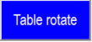 | Touch this button,table rotate  触摸此按钮，转台回转
退回  Rotary back | 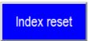 | Touch this button,rotation tower turn back  触摸此按钮，转台转回
上升  Lifting | 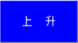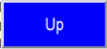 | Touch this button,table up  触摸此按钮，转台上升
下降  Descend | 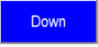 | Touch this button,table down  触摸此按钮，转台上升
模架转位  Stripper turn | 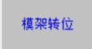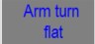 | Touch this switch, turn the stripper to put bottle on conveyor,or reset  触摸此按钮，选择脱模架翻转把瓶子放到输送带上
模架复位  Stripper reset | 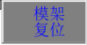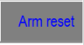 | Touch this switch, turn the stripper to reset  触摸此按钮，选择脱模架翻回复位
内冷  In-cold | 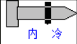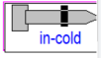 | Only work after in-cold prepare  只有在内冷预通按钮触摸后才起作用
吹气预通  Blowing prepare | 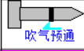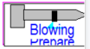 | Touch the button, Open Pre air blowing  触摸此开关，吹气预通打开
吹气  Blow air | 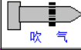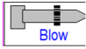 | Only work after blowing prepare  只有在吹气预通按钮触摸后才起作用
外冷  Out-cold | 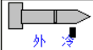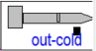 | Touch this button to open out cooling  触摸此按钮，外冷打开
- Home switcher
界面切换

- Temperature set温度设定
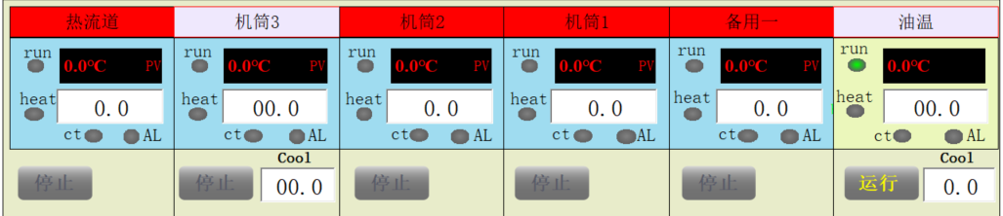
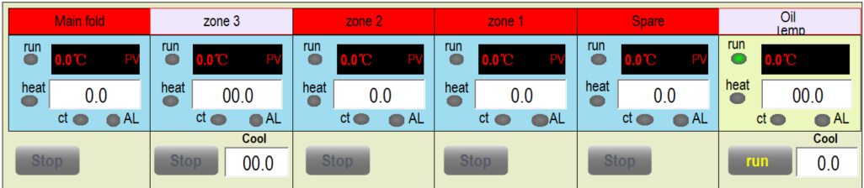


Temperature setting Touch , Temperature setting range 0-300.

温度设定部分先触摸 ，温度设定范围是0-300。
The actual value displays the current temperature, if the thermocouple disconnected, the temperature increased to maximum. You can also use this method to detect thermocouple quality. If heat preservation function ON, after reach the setting the temperature and setting time,machine can be run.
实际值显示当前的温度，如果热电偶断线，温度会增到最大值，也可以用此方法检测热电偶的好坏。如果保温选择后，设置温度到后再经过设定的时间，可以开机。

- Temperature PID preferences温度PID参数设定
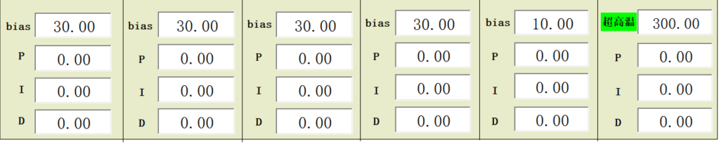
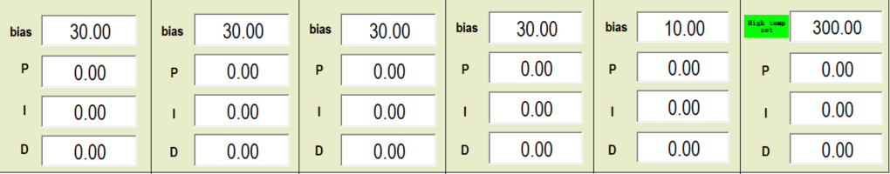
Set Upper and lower limits,when the actual temperature is within the deviation range,the temperature is raised in place.
设置上偏差和下偏差，实际温度落在偏差范围内时说明温度加温到
When the temperature is always biased, pls open the heating switch in the corresponding heating zone,after the temperature is close to the setting value,system will start self-tuning and automatically writes the P I D parameter.This process lasted about 1 hour.In general, it does not need to be reset again after adjusting PID.If the user changes the heater, please follow above steps to self-tuning.After repeated testing, temperature control within + / - 1 ℃.
当温度始终存在偏差时,需要选择加热区,开启加热开关,直至温度升至设定值附近时,系统会进行自整定,P I D参数自动写入.这个过程持续约1小时左右.一般调好P I D后不需要重新设定,如果用户更换加热器,请按以上步骤重新进行自整定.经反复测试,温度控制在+/-1℃内。
- Pressure and flow settings压力流量设定画面
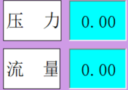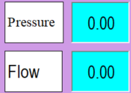
This screen sets the proportional pressure and proportional flow of each action,Pressure range from 0-140，Flow range from 0-99.
此画面设定各个动作的比例压力和比例流量，压力范围从0-140，流量范围从0-99。
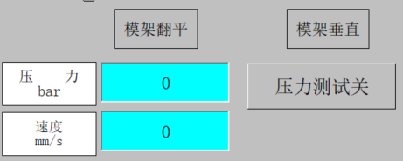

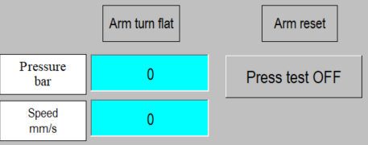

This area tests the system pressure flow,methods as follow: Set pressure flow 0, check the ammeter and output, should be adjusted minimum value to 0,the flow rate set to 0.2A.
Then set to 50/50,check whether the system pressure flow is appropriate.Set the pressure flow rate to 99/50 after adjusting to the appropriate position.Look at the ammeter value, adjust the maximum knob to make the ammeter at 0.6A.Then set pressure flow to 50/99 and ammeter value is adjusted to 0.75.
When the cylinder bottom, adjust the corresponding pressure flow is the system pressure flow
这一块可以测试系统压力流量，具体操作方法如下：先设定压力流量在0，看电流表和输出，应调整最小值到0，流量设置为0.2A.然后再设到50，50，看系统压力流量是否合适，调至合适位置后再将压力流量设为99.50，看电流表的值，调整最大值旋钮使电流表在0.6A即可，再将压力流量设置为50,99看电流表的值调整为0.75,当油缸到底时,调整相对应的压力流量也是系统压力流量。
- Linear scale set电子尺设定画面
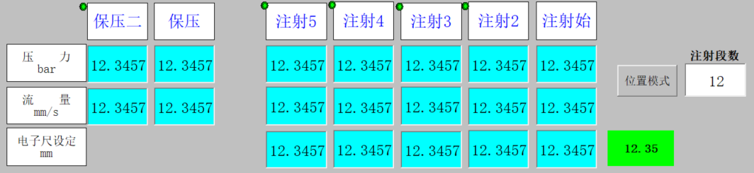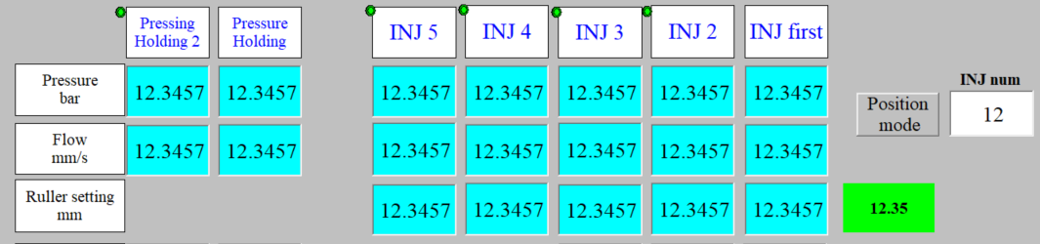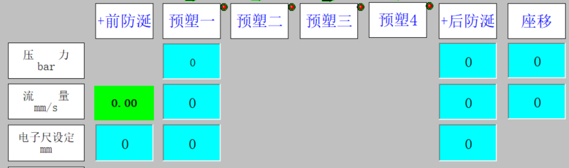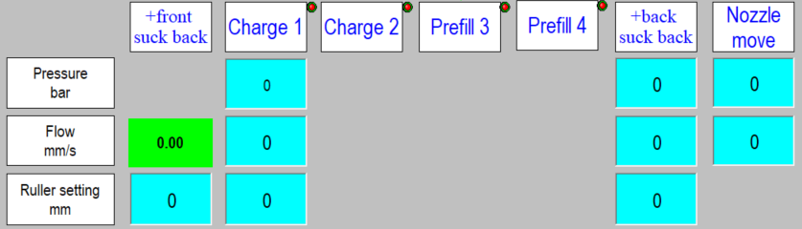
This area sets the length of the linear scale of injection and the location of each piece of injection,pls note:the position of
Injection two<Injection one<screw donusu(pre-plastic)< Anti-spillage(suck back)
这个区域设定注射电子尺的长度,以及每段注射的位置,必须遵循这样一个原则,既(注射终位置<注射2位置<注射3位置<注射4位置<注射5位置<预塑位置<防涎位置)

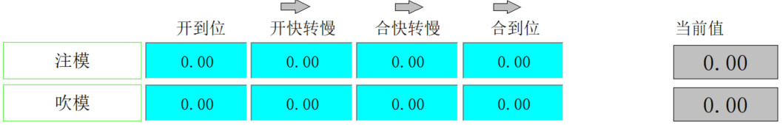

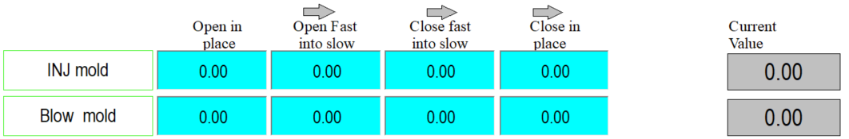

This area set the length of linear scale of open/close mold.
这个区域设定开合模电子尺的长度。
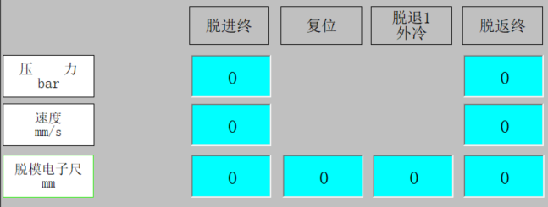

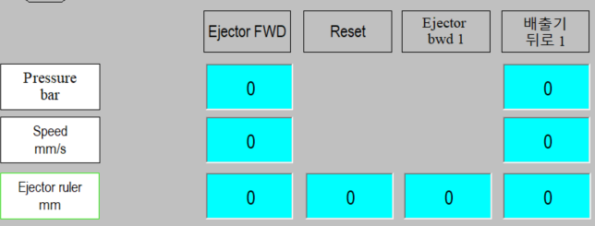

This area set the length of the linear scale of stripping.
这个区域设定脱模电子尺的长度。
Divided into 3 areas, respectively set mold opening and closing position of injection&blow mold and position of slow to fast,pls note:
- the position of mold open reached<mold open slowly<mold close slowly <mold close reached
- The rule of stripping part:the position of stripper bwd< stripper back 1< Stripping back).
分3个区域,分别设定注射模,吹塑模,的开合位置以及快转慢的位置,必须遵循 (开位置<开慢位置<合慢位置<合位置)脱模部分设定的规则是(脱返位置<脱返1<脱返)。
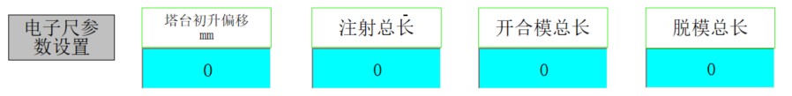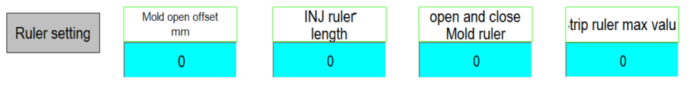
Set maximum stroke of linear scale
设置电子尺的最大行程

- Alarm recording报警信息记录
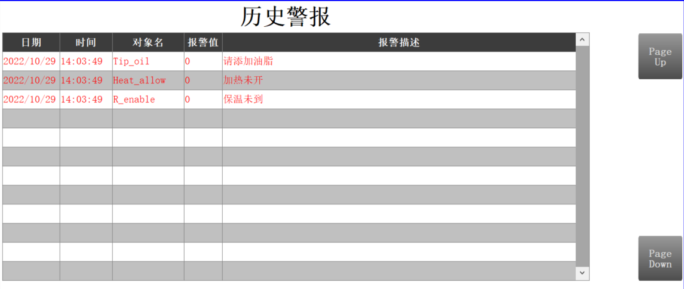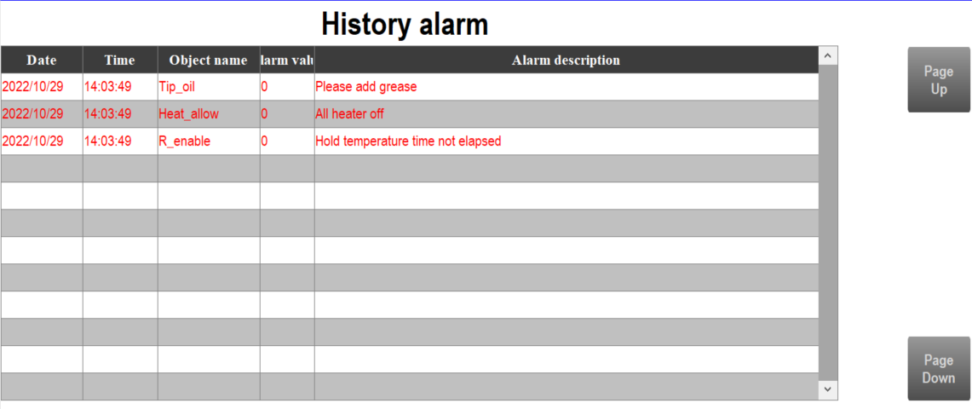
Alarm information records the alarm, including failure time,alarm content. You can use the scroll button to check the alarm information.
报警信息记录所发生的报警，有发生故障的时间，报警的内容，可以用滚动键上下左右翻看。

- Machinery preferences机械参数设定
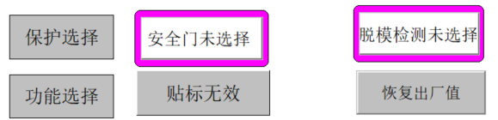
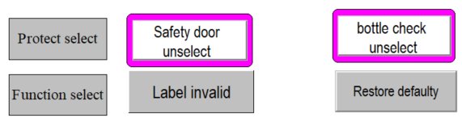
User can set parameters in the page,set corresponding parameters according to different processes
此页面设置用户需要的工艺参数，根据不同的工艺设置相对应的参数
安全门选择  Safe door OFF | 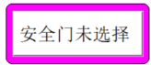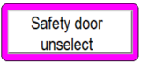 | Select the safety door,safety door switches work  安全门选择上，安全门开关起作用
脱模检测选择  Ejection inspection monitor | 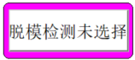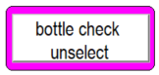 | Select ejection inspection monitor,the ejection inspection monitor switch work  脱模检测选择后，脱模检测开关起作用
贴标机选择  Labeling machine selection | 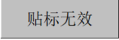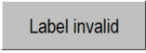 | Labeling machine selection switch, need special configuration  贴标机选择开关，需特殊配置
恢复出厂值Restoring Factory Defaults | 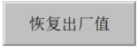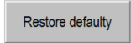 | Touch this switch, all data is restored to factory defaults  触摸此按钮，所有数据恢复出厂值

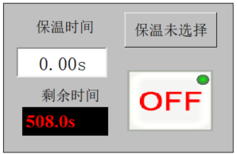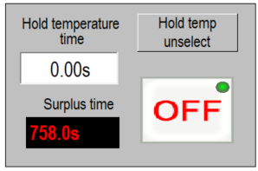
Touch this button, temperature must be within the deviation range,keep it after setting time,then machine can be run.
保温选择选择后，必须温度在偏差范围之内，保持在设定的时间后才可以开机。

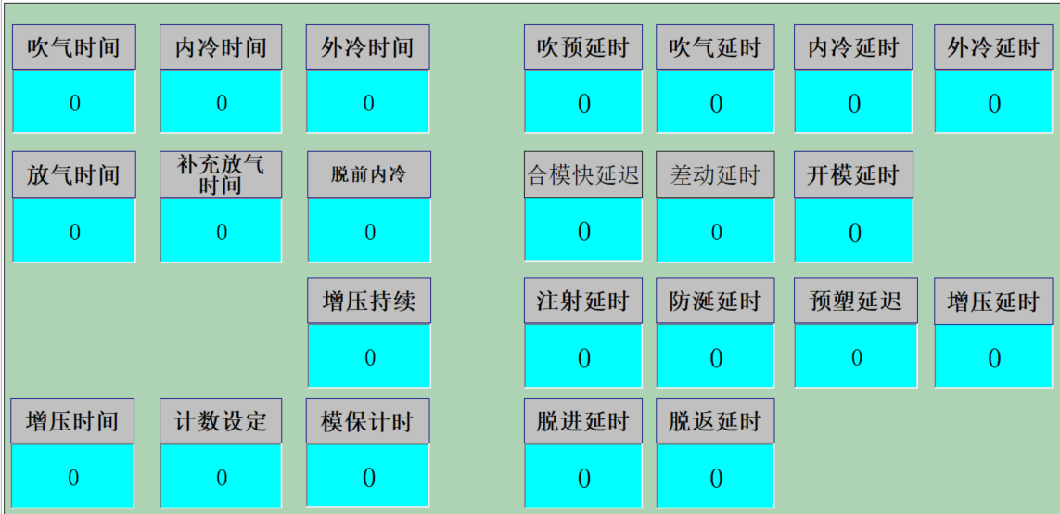
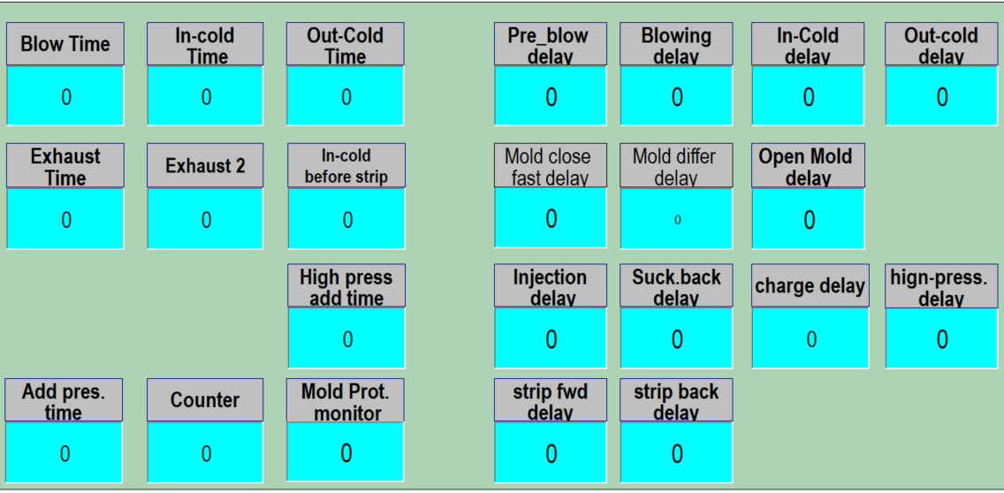

Set the time and counter according to the process of different products.
根据不同产品的工艺，设定时间，并能够设定计数。

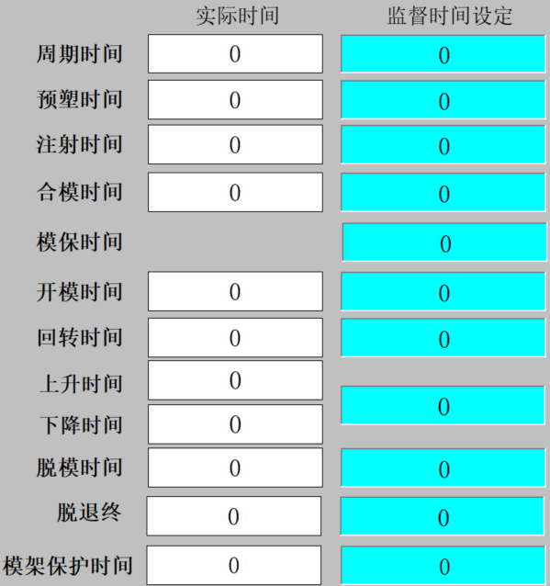
- Action time monitor动作时间监视

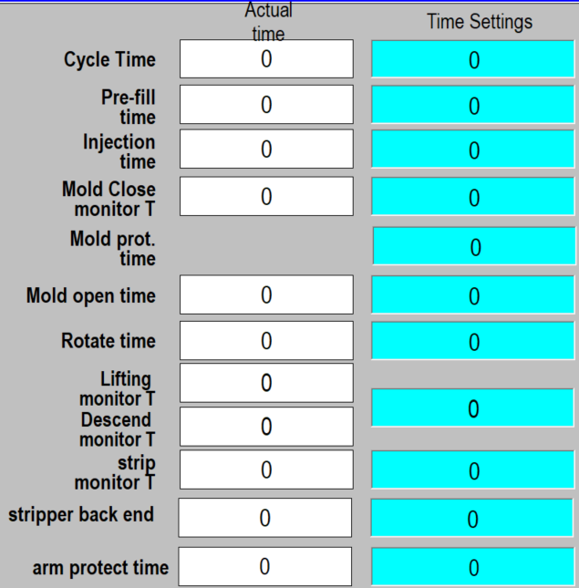

This screen shows the actual action time and supervision time.
此画面显示实际的动作时间和监督时间。

- Input monitor输入监视
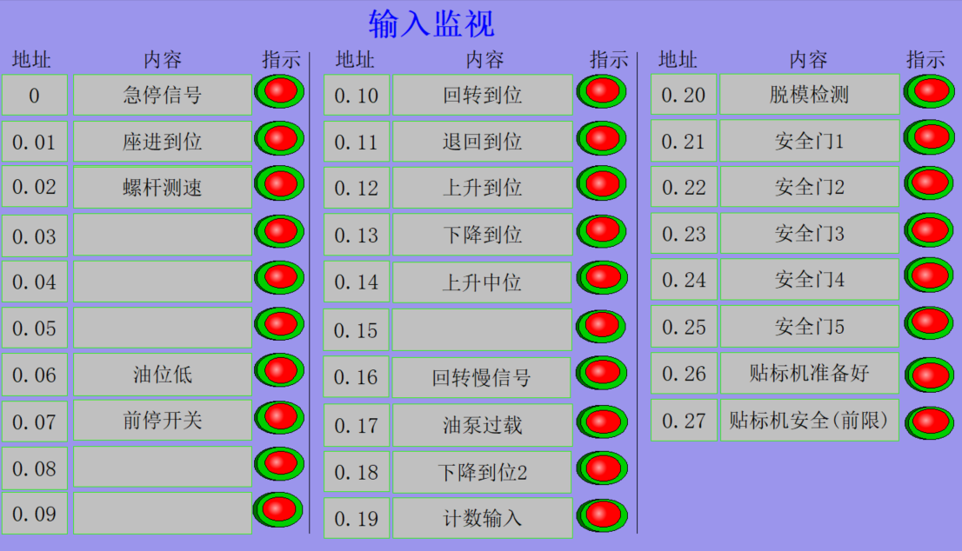
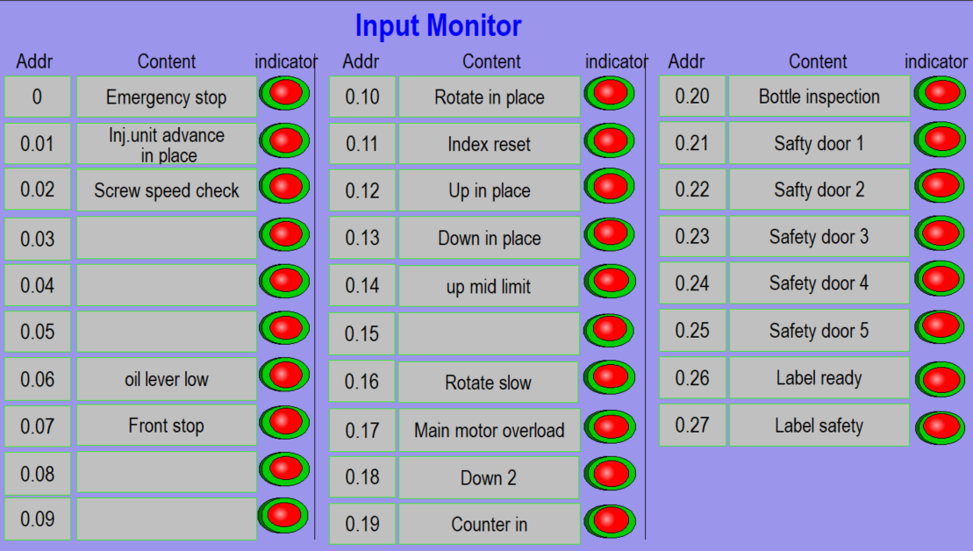

Input monitor shows the input of the address and status.
输入监视显示输入的地址和状态。
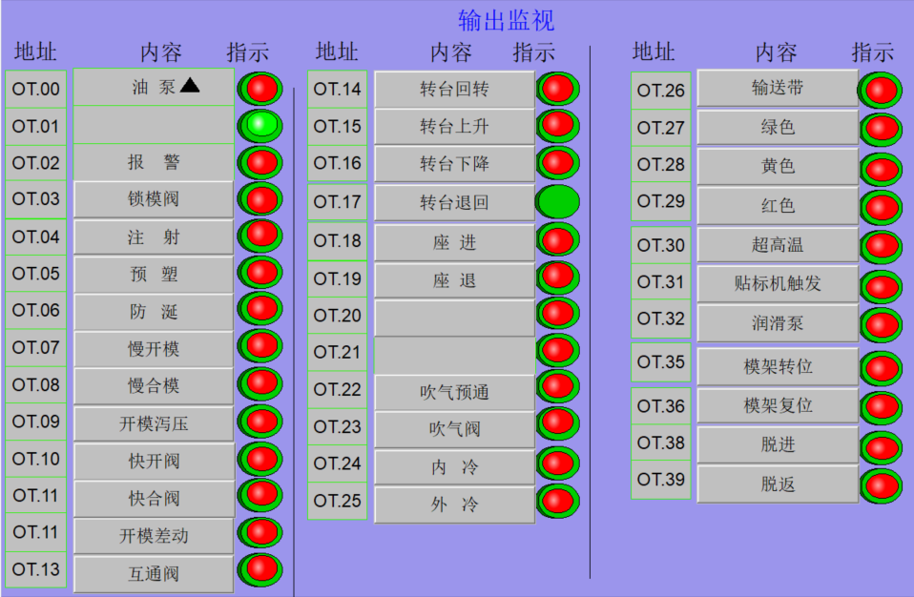
- Output monitor输出监视

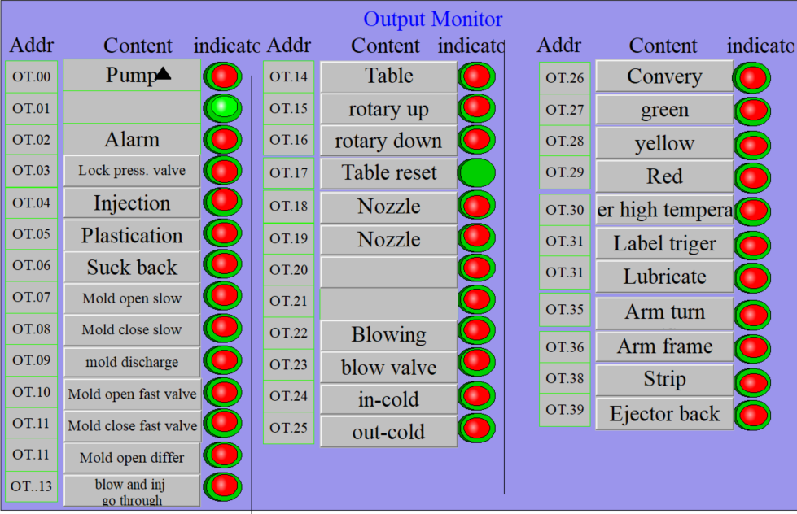

Output monitor shows the output of the address and status..
输出监视显示输出地址对应地址的状态。
- Parameter access参数存取画面
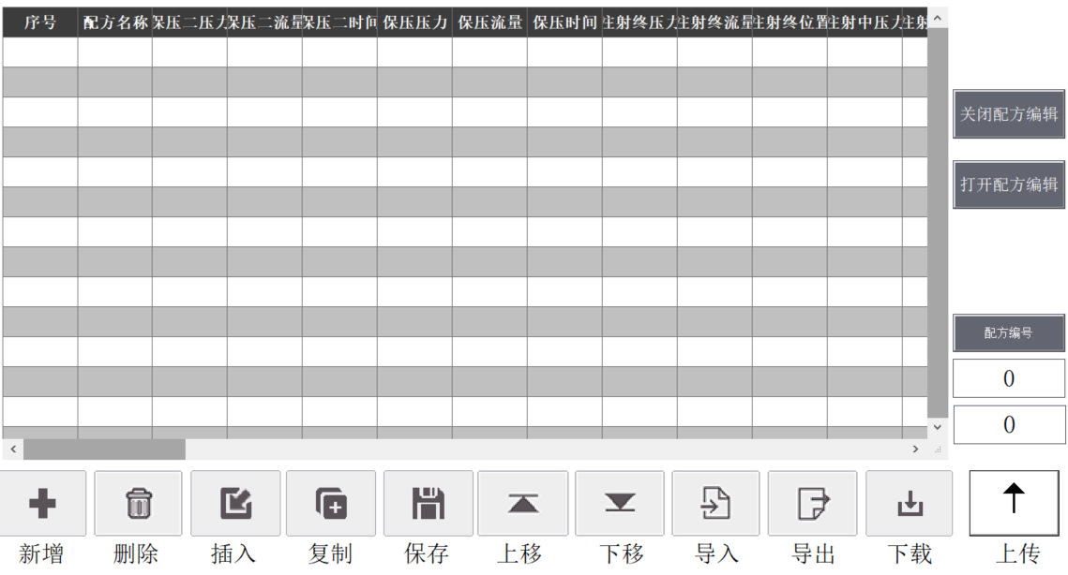
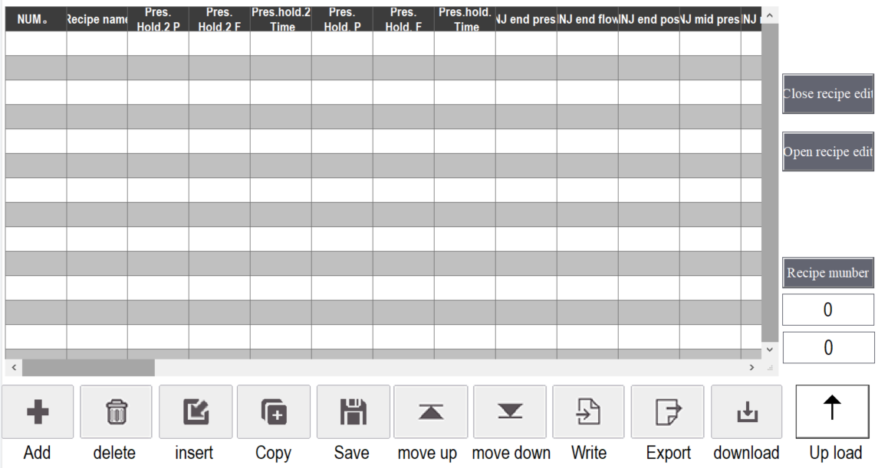


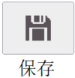
Click here to save the current process data.
点击此处,存储当前工艺数据。

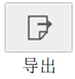
Click here to save the cerrent process data
into memory card or hardcard.
点击此处,将当前的数据存储到硬件卡或者是存储卡
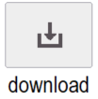
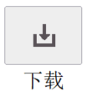
上。
Click here to transfer the current process data.
点击此处,调用当前工艺数据。
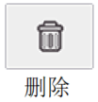

Delete unwanted prescription.
删除不想要的配方。

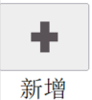
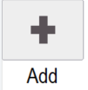
Touch here, you can add new formula.
触摸该处,可以增加新配方。

- Cycle curve周期曲线
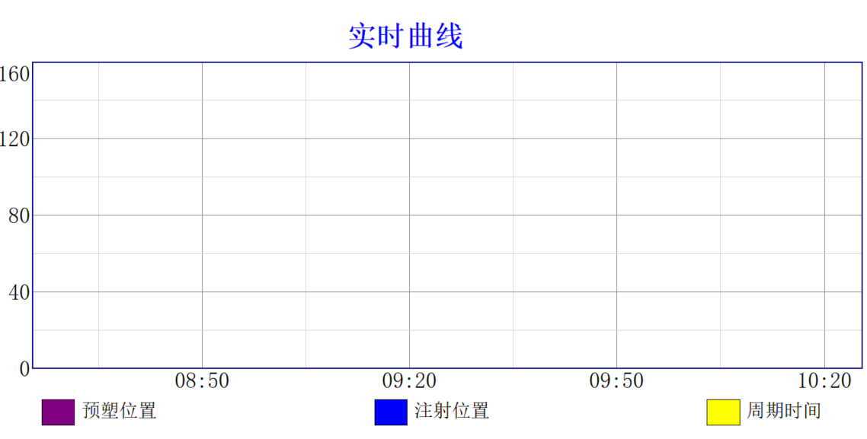
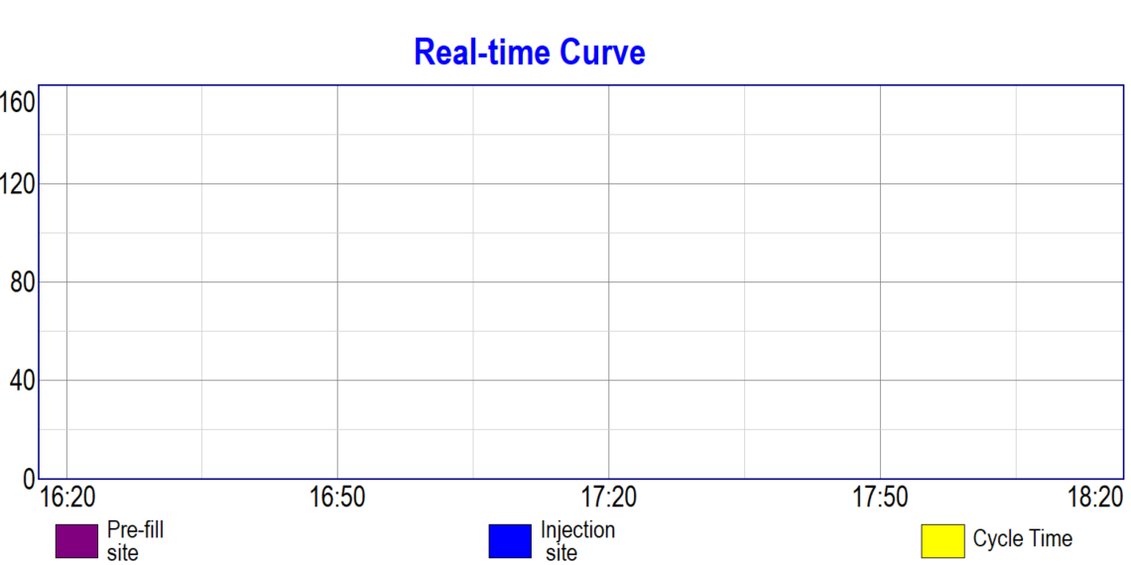

This page shows cycle time,pre-plasticizing position,material charge position.Customer can check last 20 mold shots running data.
这个屏幕提供每模的周期时间,预塑位置,注射位置.用户可以查看最近20模的运行数据。
- Statistics数据统计
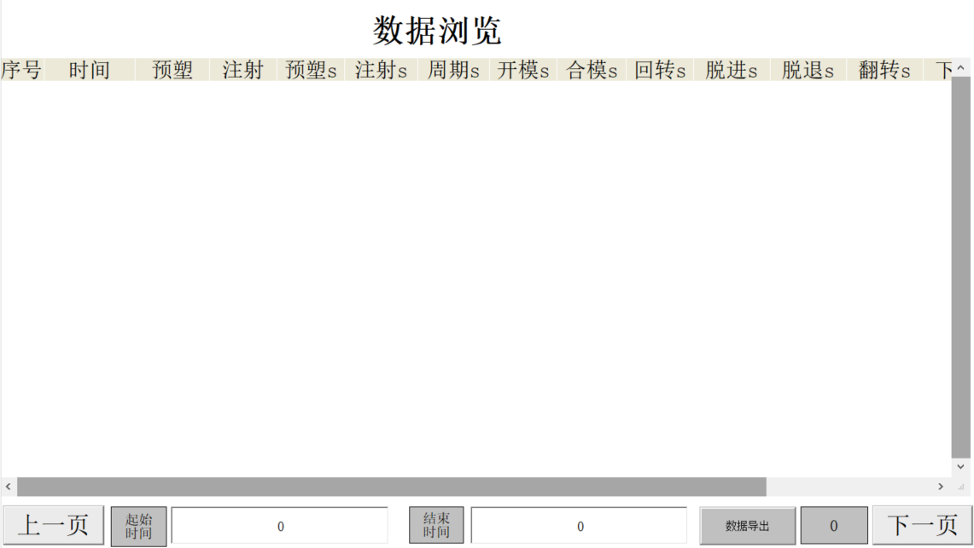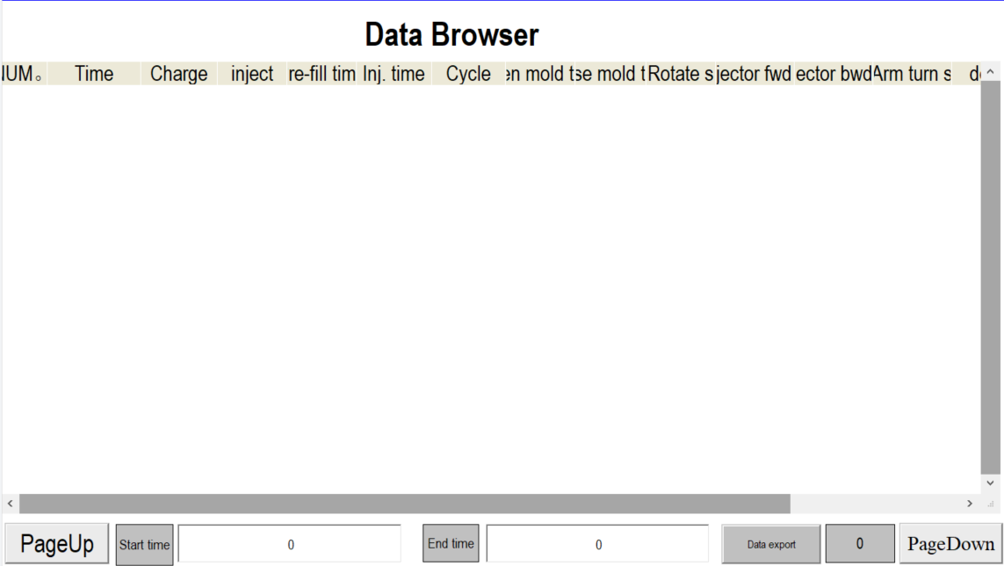

This page counts the time of each action for last 10 shots mold.
此页面统计各个动作的时间，记录1-10模。
- Operation运行
- Manual operation手动操作
All the detailed parameters of the machine have been set before it leaves the factory. Please do not modify the machine if you are not familiar with it.
本机器出厂前调试时，各详细参数都已设定，不熟悉本机操作人员请不要随意修改。
（1） Open the heating switch. 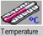 Set proper barrel and hot runner temperature.
When using different raw materials, the temperature setting needs to be changed.(attached form.3 for your reference)
打开加热开关，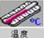将机筒及热流道等调至适当温度值
使用不同原料时温度设定需要变更，不同塑料温度设定见（附表三）
(2) Open the air and water switch.
打开气源、水源开关
- Choose “manual” button. 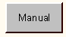
- 操作选择 “手动”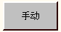按钮
(4) Press the 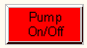 button, start the pump
Motor rotation direction should be correct,if reverse,should immediately press the emergency stop button, at the same time the power supply into the line commutation
按下“油泵起停”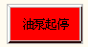按钮，启动马达，马达旋转方向应正确，如反向应立即按下急停按钮，同时把电源进线换相
(5) Press 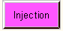 button, the screw will move forward (Attention: The temperature of the barrel is not reached or the plastic is not completely melted. "injection", "pre-plastisizing" and "suck back" are strictly prohibited!!!).
按“注射”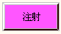按钮，螺杆即向前（注意：机筒温度未达到或塑料未完全熔化，严禁进行“射胶”“预塑”“防涎”动作!!!）。
(6) Open the hopper block
打开料斗闸板
(7)there is linear scale setting in page of time setting to control stroke of injection,pre-plastisizing and suck back.Please make sure the parameter setting is correct according to mold data sheet
在时间设定界面中有电子尺设定，其内容决定注射，预塑，防涎行程。请确定其参数设置，已经按照实际工艺要求设定正确
(8) Press “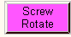” button, the screw will rotate and backwoad to feed material in barrel.
按“预塑”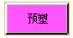按钮，螺杆旋转并后退，给机筒储料
- Press , inject the melted plastic material(test the material charging first,don’t charge the material into mold).Oil pressure should not be too high (no higher than 30kg/cm2) to avoid molten material splashes into people.After material injection, press “” button to feed material in barrel.
and inject the material without mold, pay attention to the injeciton pressure can not be very high (less than 30kg/cm2), avoid the material sputtering.
按“”按钮，将熔融料射出，进行“离模空射试验”，注意，油压不宜过高（不可高于30kg/cm2），以免熔融料飞溅伤人，离模空射试验后，按“”按钮，使机筒重新储料
(10) Press “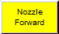” button , let the barrel nozzle touch the mold, adjust the nozzle limit switch to adjust the forward and backward stroke of the nozzle(The nozzle limit switch is only useful when semi-auto or automatic)
按“座进” 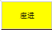按钮，使射嘴接触模嘴，并调节射嘴限位开关，调整射嘴前后行程（射嘴限位开关在半自动或全自动时才有用）。
(11) Close the safe door, press “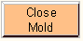” button,let mold close
关上安全门，按“合模”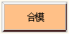钮，使模具闭合。
(12) press 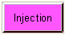 button, injection the melted material into mold.
按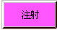按钮，将熔融料射入模。
(13) press 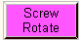 button, feed the material into barrel again, and then press “Low blow”, 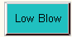 “High blow”, 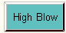 “Stripping Forward”, 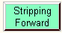 “Stripping Arm turn up”, 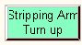 “in-cold” 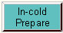, “out cold”, 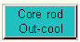 “stripping back”. 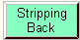
按“预塑”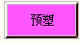按钮，使机筒重新储料，然后依次按动“吹塑预通”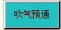 “吹气”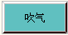 “脱模进”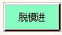 “模架转位”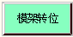 “内冷”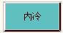 “外冷”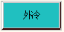 “脱模退”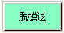
(14) After cooling time, press “mold open” 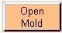button, open the mold
冷却时间到后，旋动“开模”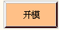按钮，开启模具
(15) press “rotary” button, rotate the table 120 degree. 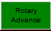
按转台“回转” 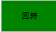钮，使转台回转120°
(16) press “rotary back” button, move the rotation tower back。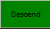
按转台“退回” 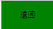钮，使转台回转120°
Repeat action M to T, adjust the injection volume and injection pressure till the product in good quality.
重复M至T动作，调定射胶容量和射胶压力，直至制品合格为止。

- Semi-auto operation半自动运行
Semi-automatic operation requires closing the safety door,start from rotary advance to table up,complete a semi-automatic cycle.
半自动操作需关上安全门，转台回转开始，直至转台上升，至此完成一个半自动循环程序。
After the manual operation, press“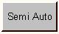”into semi auto mode(other operations no need change) Press the button of Auto Start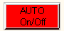, the machine will finish the actions from table down,mold closing, injection, pressure hold,blow air, pre-plasticizing,suck back, cooling, stripping, mold opening,table up,table rotate. After a circle is finished, press the button again, the machine will start the next circle. Normally it is used in the period of the machine running without material or start-up stage.
经手动操作后，然后将操作选择选定“半自动”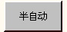（其余操作程序不变），按下 “自动启停” 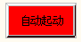按钮，机器依次完成转塔下降、合模、注射、保压、吹塑、预塑、防流涎、冷却、脱模、开模、转塔上升，转位等动作。一个循环结束后，再按一次“自动启停” 按钮，则机器重新进行下一个循环。一般在空运转试车和生产开始阶段使用。

- Auto operation自动运行
After semi-auto operation, other operation don’t changed. press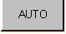; press the button , the machine will continuously and circularly automatically complete the technological process and various actions according to the chosen program.Under normal production conditions, the machine is fully automatic operation.To stop the operation of the machine, press the "" button,the machine will automatically stop at the beginning of the cycle after the completion of this cycle.
经半自动操作后，其它操作程序不变，将选择开关选定“自动” 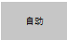位置，按“自动启停” 按钮，机器即按选定的程序连续地，周而复始地自动完成工艺过程和各个动作，在生产正常条件下，本机器均在全自动状态下运行，若要停止机器运转，则按“自动启停”按钮，机器在自动完成本循环后自动停止至循环起始位置。

- Special configuration instructions特殊配置说明

