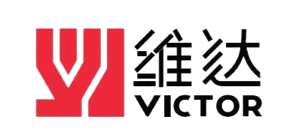

MSZ30
塑料注吹中空成型机使用说明书
Injection Blow Molding Machine
Operation Manual

Jiangsu Victor Machinery Co., Ltd 江苏维达机械有限公司
Address: No.1 Huafang South Road., TangqiaoTown, 中国江苏省张家港市
Zhangjiagang City, Jiangsu, China 塘桥镇华芳南路1号
Web: www.victorcn.com www.victorpm.com
Tel: +86-512-58441128 （市场部），58921397 （Exporting）
+86-512-58437198（服务部，service）
+86-512-58921230（技术部）
Fax: +86-512-58432128
© 2025 Copyright Injection Blow Molding Machine, all right reserved.
Printed in the Peoples Republic of China
Version手册版本 2025.1
出版状态 应用
版权 2025©江苏维达机械有限公司，版权所有，保留相应权利

Table of contents 目录
DISCLAIMER免责声明 5
Foreword前言 6
Chapter 1 Safety information第一章：安全信息 8
1.1 Important！注意 8
1.2 How to use and keep this manual说明书使用注意事项 14
1.3 Warning signs警告标志 15
Chapter 2 Introduction of the machine第二章：设备介绍 16
2.1 Application scope适用范围 16
2.2 Structure of the machine机器结构 16
2.2.1 Mechanical parts机械部分 17
2.2.2 Hydraulic system液压系统 26
2.2.3 Pneumatic system气动系统 34
2.2.4 Electrical system电气系统 35
2.3 Nameplate铭牌 37
2.4 Main technical parameter of the machine主要技术参数 38
2.5 Environment使用环境 39
Chapter 3 Lifting、transport and store第三章：吊装、运输和储存 40
3.1 Lifting吊装 40
3.2 Store储存 41
3.3 Transport运输 41
Chapter 4 Installation第四章：安装 42
4.1 Important！注意 42
4.2 Working area requirements工作区域要求 43
4.3 Installation安装 44
4.3.1 Preparation准备工作 44
4.3.2 Mechanical connection机械连接 44
4.3.3 Electrical connection电气连接 44
4.3.4 Other connection其他连接 45
Chapter 5 Operation第五章：操作 46
5.1 Checking检查 46
5.2 Operation运行 48
5.2.1 Unload test-run空转试运行 49
5.2.2 Load test run负载运行 50
5.2.3 Manual operation操作 53
Chapter 6 Maintenance第六章：维修 54
6.1 Oil changing换油 54
6.2 Lubrication润滑 54
6.3 Disassembling and cleaning cylinder and screw stem机筒、螺杆的拆卸和清洗 56
6.4 Other其他 57
Chapter 7 Troubleshooting第七章：故障排除 58
Chapter 8 Attached figures&list第八章：附图附表 61
8.1 Layout drawing of machine机器排布图 61
8.2 Hydraulic scheme液压原理图 64
8.3 Hydraulic part list液压元件清单 65
8.4 Seal ring unit密封件清单 67
8.5 Pneumatic scheme气动原理图 70
8.6 Pneumatic part list气动元件清单 71
8.7 Grounding Precautions接地注意事项 72
8.8 Equipment troubleshooting manual设备故障解决手册 73
8.9 Electric scheme电气原理图 75
8.10 Daily maintenance日常保养事项 75
Chapter 9 Special configuration instructions第九章：特殊配置说明 75

DISCLAIMER免责声明
1. This document is the proprietary of Jiangsu Victor Machinery Co., Ltd. furnished for customer use only. No part of this book shall be reproduced, stored in retrieval, or transmitted by any means, electronic, mechanical, photocopying, recording, or otherwise without the written permission of Jiangsu Victor Machinery Co., Ltd. While every precaution has been taken in the preparation of this book, the publisher assumes no responsibility for errors or omissions. Neither is any liability assumed for damages resulting from the use of information contained herein.
本书中的信息归江苏维达机械有限公司所有，仅供客户使用。未经江苏维达机械有限公司的书面允许，本书的任何部分不允许被复制、储存，或者以电子、机械、影印、记录方式传播。由于此书在准备过程中已经十分谨慎，出版者声明，不对书中的错误和遗漏及此中包含的信息的使用过程中造成的损失承担责任。
2. Jiangsu Victor Machinery Co., Ltd reserves the right to make changes without prior notice. To this document and the products it describes. Jiangsu Victor Machinery Co., Ltd shall not be liable for technique or editorial errors or omissions made herein; no for consequential incident and damages resulting from use of this document.
江苏维达机械有限公司保留变更的权利，不必另外通知。对于这个文件以及它描述的产品，江苏维达机械有限公司不必对技术上和编辑上的错误和遗漏负责，也不必对使用这个文件而造成的事故和损失负责。
3. Even though Jiangsu Victor Machinery Co., Ltd has tried its best to prepare this manual, it should only be considered as a guide, which cannot replace good technique judgment. And since we are unable to predict everything in future, it is impossible for this manual to contain all technical and safety information. Please contact us if any problem arises during installation, configuration, and operation.
这个手册是江苏维达机械有限公司竭尽所能做出来的，它只是个参考。因为我们无法预测所有可能出现的情况，所以本手册没有汇集所有的技术、安全信息，如果在安装配置和使用过程中有任何疑问，请联系我们。
4. The choice of system components is the responsibility of the buyer, and it’s none of our business for the manner they are used. However, our sale team and application engineers are always available to assist you in making your decision.
系统组成的选择是买方的责任，它们如何使用与江苏维达机械有限公司无关。不过，我公司的销售人员和产品应用工程师随时可以帮助您作出决定。

Foreword前言
Dear customers:
亲爱的用户：
First of all, thank you for buying our product: MSZ30 Injection Blow Molding Machine.
首先，感谢您选购我们的产品: MSZ30注吹中空成型机。
For a correct identification of the equipment please refer to the code number shown on the acknowledgement of order, on the invoice and on the equipment itself.
请根据订单、发票和直接安装在设备本身的序列号对设备进行确认。
All the products described in this catalogue are manufactured according to high quality control procedures. Starting from the processing of the order to the technical service after delivery, is carried out in a controlled manner that guarantees the quality standard of the product.
本目录中的所有产品的生产过程均符合高质量控制程序，从订单处理到售后技术服务都处于严格的控制，保证了产品的质量标准。

This instruction manual must be read through and observed because it contains further information on the machine’s intended use and its safe operation. If the customer follows normal precautions for this type of equipment together with the instructions given in this manual, operation is safe.
您必须通篇阅读本说明手册并遵守其中的要求，因为该手册中包含设备即定用途和安全操作方面的附加信息，如果用户遵守这本手册中相关该设备的预防警告指示，则对该设备的操作都是安全的。
It can be referred to the instruction manual on the aspects of storing, lifting, transporting, commissioning, operating and maintenance. Please read the instruction manual though before using the machine for proper, efficient and safe use. The instruction manual shall be regarded as a part of the machine and appropriately kept until dismantling of equipment.
设备的存放、吊运、运输、调试、操作和维护均应依照本说明手册的要求。在使用设备之前，为保证设备的正确、有效和安全使用，相关人员应通读本说明手册的内容。该手册应被视为设备的一部分妥善保存，直至设备拆除。
The machine is designed for use by trained operators and supervisors. The owner of the machine and anyone responsible for the use of the machine must ensure that the machine is used by competent and authorized persons.
该设备限经过培训的操作手和监理人员使用。设备的所有者和任何对设备的使用负责的人员必须确保设备只能为能够胜任的指定人员所用。
The operators must make sure that they have really understood the machine function as well as all safety and warning information. It is forbidden to operate the machine by any unauthorized persons for any reasons. All operators must be trained so that they will be aware of what they should do in any emergency case. Only the competent person familiar with the machine function and application are permitted to carry out installation, operation and maintenance. These persons must know the details on foreseeable potential hazards. The machine may only be operated, serviced and repaired by duly authorized, trained and instructed personnel. These persons must be informed of details for all the foreseeable potential dangers.
操作手应确保能够真正理解设备的功能、所有安全和警告信息。未经许可，任何人不得以任何理由操作本设备。所有的操作手均须参加培训，以知晓如何应对紧急情况。只有能够胜任的、对设备的功能和使用熟悉的人员才能进行设备的安装、操作和维护。这些人员必须知晓可预见的、潜在危害的详细情况。该设备的操作、维护和维修只能由指定的、经过培训并接受委派的人员完成。必须将所有可预见的、潜在的风险详细告知这些人员。
No one may work on the machine or remain in its vicinity if they are not completely fit both physically and mentally, otherwise it may cause injured or damage. It is not our responsibility for the injury, damage or loss of property caused by incompetent persons who operate or maintain the machine against the rules.
体力或智力不是完全符合要求的人员不得操作该设备或在该设备附近逗留，否则，将可能导致人员伤害或设备损坏，对于不能胜任的人员不遵守本说明的要求，对设备进行违规操作和维护所导致的人员伤害、设备损坏和财产损失，我方不承担任何责任。
We are only responsible for machine which remains the same configuration as first installation. It is forbidden to reconstruct machines without permission. Any change in machine configuration or construction must be carried out by our stuffs or persons authorized by us. We are not responsible for injury caused by using spare parts unoriginally provided.
我方只对保留首次安装相同配置的设备负责，未经许可，禁止对设备进行改造，设备配置和结构的任何改动均应由我公司职员或我方指定的人员完成，对于非原装供货的备品备件所导致的人员伤害，我方不承担任何责任。
The contents and drawings or pictures attached to the instructions are commercial secret and forbidden to be copied, duplicated, exhibited or sold.
手册中附的内容和图纸/或图片为商业机密，不得进行拷贝、复印、展览和出售。

Chapter 1 Safety information第一章：安全信息
- Important！注意
1.1.1 The machine has been designed and built in line with the safety standard and is safe when operated correctly. Safety of the operating person was one of the basic concepts underlying its design. All machines are potentially dangerous if they are operated incorrectly, used for purposes other than those for which they were built or are operated by persons lacking the requisite know-how, training or sense of responsibility.
该设备的设计和建造符合安全标准的规定，在正确操作的情况下是安全的。操作人员的安全是我们在设备设计时最优先考虑的基本理念。如果操作方法不正确、用于非即定用途或由缺乏必要的生产经验/未经过培训/缺乏责任感的人员操作，那么所有的设备都存在潜在的危险。
1.1.2 For your personal safety, please read this instruction carefully, know well the intended use and restriction as well as the potential hazards associate. These cases causing hazards are various, for example:
出于贵方人员的安全考虑，请仔细阅读本说明，通晓设备的既定用途、限制和相关的潜在危害，以下情况所导致的危害会很严重，例如：
- incorrectly operate or operated by unskillful operators;
操作方法不正确或由没有经验的操作手进行操作；
- partly or whole disobey this instruction manual;
未遵照本说明手册的部分或全部内容；
- incorrectly installed;
安装不正确；
- failure of power supply;
断电；
- severe maintenance fault;
严重的维护故障；
- change the data or operate randomly;
随意改变数据和操作；
- use irregular spare parts;
使用不正规的备件；
- special accident;
特殊事故；
- etc.
其他等。
1.1.3 The owner must clearly define exactly who is responsible for setting-up, operation and maintenance and is obliged to ensure that the machine is only operated in safe working order.
设备的所有者必须清楚明确地指定启动、操作和维护负责人，并须确保设备的操作只能在安全的工作秩序下进行。
1.1.4 The operator is obliged to immediately remedy all damage or changes in the machine which may impair its safety (provided that he is authorized to do so) or must report these without delay.
操作手必须立即对可能损害设备安全性的所有设备损坏和改动进行补救（如果在其职责范围内），否则，必须立即将上述情况报告相关人员。
1.1.5 Non-professional person don’t access; all the visitors must keep a safety distance.
非专业人员不得接近设备，所有参观人员必须与设备保持安全距离。
1.1.6 When unloading and installing the machine, it is important to ensure that the load carrying capacity of the lifting gear is sufficient to bear the weight of the machine.
在卸载和安装设备时，确保升降装置的承载能力足够承受设备的重量是非常重要的。
1.1.7 Signs referring to product safety and other safety stickers must be checked regularly and cleaned. They must be replaced if they are no longer clearly legible at a reasonable distance.
应定期检查并清洁与产品安全有关的标志和其它安全招贴。如果在合理的距离内不能清楚识别，则应该更换新的标志和招贴。
1.1.8 All safety mechanisms must be checked every time before starting up the machine and must ensure that all protective devices are fitted in position and act normally. Ineffective/failure safety devices must be replaced in time once they are discovered or if it can not be replaced the machine must be shut-off. Any protective mechanisms which have been removed for setting-up, retooling, repair or maintenance work must be replaced before switching on the machine. Make sure they are always in perfect working order.
每次启动设备前，必须检查所有的安全机构，并确保所有保护装置均已安装就位且能正常发挥作用。一旦发现安全装置无效/故障，必须及时更换。如果不能及时更换，则必须关闭设备。在接通设备之前，为便于设备的启动、改装、维修或维护而暂时拆除的所有保护机构必须装回原处并确保其处于理想的工作秩序下。
1.1.9 Ensure danger conditions to the operators are eliminated before opening the machine.
在打开设备之前，应将威胁操作手的危险情况清除。
1.1.10 Covers must not be opened or maintenance work started until the machine has been switched off, all rotating part have come to a complete stop and the machine has been secured so that it cannot be switched on again inadvertently (lockout or warning sign on the master switch).
在关闭设备、所有运动部分完全停止和将设备固定以免其意外接通之前（主开关上有闭锁或警告标志），不得将防护罩打开，也不得开始维护工作。
1.1.11 Machine parts and safety mechanisms must not be removed, modified or bypassed.
不得拆除、更改或旁通设备的零件和安全机构。
1.1.12 Do not use in danger circumstance.
不得在危险环境下使用该设备。
1.1.13 Keep good lighting in the working areas.
工作区内应保证良好的照明。
1.1.14 The product must be set up in factory field to use, and must avoid lightening strike, don’t use in moist place or where rains.
该设备必须在洁净、通风、地面平整的室内区域中使用，必须防雷击，且不得在潮湿的地方或下雨的地方使用该设备。
1.1.15 Let the machine operate under the speed designed. Don’t force the machine or auxiliary devices to operate.
设备的操作速度必须符合设计要求，不要强迫设备或辅助设施进行操作。
1.1.16 Loose-fitting garments, long hair, wristwatches and jewelry can lead to accident at work (e.g. snagging, being trapped by belt etc.). For this reason:
外衣宽松、长头发、腕表和珠宝都有可能导致工作事故，因此：
- Don’t wear any loose-fitting garments;
不要穿着宽松的外衣；
- Cover you hair;
将头发包裹起来；
- Remove wristwatches and jewelry.
将腕表和珠宝取下。
1.1.17 Ensure that the workplace is kept clean and tidy. Dirt (e.g. oil or dust on the floor) and obstacles can impair your safety. Ensure above all that the guides in the machine are kept clean, as dirt will lead to greater wear and may cause fires.
应确保工作地点保持干净整洁，污物（例如地板上的油和尘土）和障碍物将会对您的安全造成损害,最重要的是要确保设备上所有的工作台都保持清洁，因为上面的灰尘会导致较严重的磨损和火灾。
1.1.18 Wear protective clothes, gloves, shoes and safety helmet at work.
工作时应穿着工作服、劳保手套、劳保鞋和安全头盔，如有需要，应提防尘口罩。


1.1.19 Post a list with emergency phone numbers nearby the working area.
在工作区域附近贴上急救电话号码。
1.1.20 Operators should be aware of what to do in case of an emergency (refer to the Procedures for Emergency Situations); know the location of the first-aid-kit, and the location of the fire extinguisher. Also learn how to use a fire extinguisher.
发生紧急情况时，操作手要知道急救箱的位置以及灭火器的位置，还要知道如何使用灭火器。
1.1.21 In order to prevent back injury, heavy parts (or units), must be moved by two or more persons or relative lifting equipment.
为了防止身体受伤，在搬运重部件（或装置）时，一定要由两个或两个以上的人搬运或使用起重设备。
1.1.22 Before maintenance pressured parts in the machine, you must release the pressure in the pressured system. At the same time, Do not stand in the direction facing the charger, the operator should on the opposite side and remember do not strike, press or transfer until it is discharged.
在维护具有压力的装置时应先释放压力装置的压力，然后才能进行维护，在释放压力时应避免直接对人，并在压力完全释放前不要敲打、挤压、移动承压装置。
1.1.23 The machine has high-voltage devices installed such as the electrical cabinet, which represents electrical hazards. Therefore, special care is required during the maintenance or inspection work in locations where such devices are installed.
机器中有高压装置（如电气柜）存在电危险，因此在此装置位置上的检测和维修要特别小心，不正确的重新组装，在以后的使用中可能引起触电。
1.1.24 Do not put anything over the power line and control line etc. Put the machine in a place where the power line etc. will not be stepped or make people stumble.
切勿将任何东西压放在电源线和控制线上，应将本机安放在电源线不会被踩踏或使人绊倒的地方。
1.1.25 The gaps and hatches on the machine are for ventilation to avoid the machine overheating. Therefore, do not block or cover them. Do not keep the machine near to the radiator or the place which have no appropriate ventilation devices.
机器上的缝隙和开口用于通风以防本机过热，所以请勿堵塞或掩盖这些开口，切勿将本机放置在散热器附近或没有适当的通风设备的地方。
1.1.26 Powering the tool with people working around is extremely dangerous. Therefore, shut it down and apply a lockout device. This action prevents anyone of powering the Tool without the agreement of people working around it.
启动设备时，对于正在设备上维护人员是非常危险的，因此，关闭设备并用锁将主开关锁定，这样会防止人们在没有经过正在作业人同意的情况下启动设备。
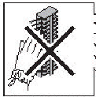
1.1.27 Do not put anything to the machine through the machine gap; otherwise it may cause fire or electrical shock. Do not spray any liquid to the machine.
切勿将任何东西从机壳缝隙塞入本机内，否则会引起火灾或触电。切勿将任何液体泼洒在本机上。
1.1.28 Before leaving the machine unattached, the control voltage must be switched off and the machine secured so that it cannot be switched on inadvertently (lock or warning sign on the master switch).
在断开设备连接之前，必须将控制电压切断，并将设备固定以避免意外接通（主开关上有闭锁或警告标志）。
1.1.29 Be careful not to touch power terminals blocks of AC power box and make sure to shut the power down before any maintenance or inspection work.
小心不可触碰交流电力箱中的带电端子板以及确定维修之前要关闭电源。
1.1.30 Operator is not allowed to leave his work station when the machine is in operation.
当机器运行时，操作手不得擅自离开工作位置。
1.1.31 Please do not press the bonnet with hand or heavy goods.
不要用手或重物按压机罩。
1.1.32 The permissible noise level depends on the national regulations and standards prevailing in the owner’s country. Additional noise abatement measure must be taken by the owner if the applicable limit values are exceeded on account of exceptional circumstances in individual instances.
许可的噪音等级应视设备所有者国家的现行规定和标准而定。如果在个别情况下，基于例外原因，超出了适用的噪音限值，则设备所有者必须采取额外的噪声抑制措施。
1.1.33 The machine shall be serviced adequately, as lubricated and adjusted, but don’t serviced in working state. Installing, maintaining, cleaning, dismounting must be carried out after power cutting off, machine stop and safety protective measure taken.
应给与设备足够的维护，如润滑和调整，但是请不要在工作状态下进行。只有在切断电源、设备停机并采取安全防护措施之后，才能进行设备的安装、维护、清洁和拆除工作。
1.1.34 Always uses proper hand tools and jigs during maintenance or inspections. Before operating the machine, check for any hand tools or jigs left inside it. For your own safety, never try to remove them with the machine under operation.
在检测或维修设备时要使用合适的手用工具和夹具，在运行设备之前，一定要检查工具和夹具是不是留在设备里，为了自身的安全，千万不能在机器运行时将工具从机器里拿走。
1.1.35 Use suggested fittings, check out them in the manual.
请使用荐用配件，并手动对其进行检查。
1.1.36 A log should be kept to note any problems encountered faults or incidents which occur and maintenance carried out under the responsibility of the user.
应保留工作日志，以便记录下故障和事故中遇到的问题和设备的使用者出于自己的职责而采取的维护措施。
1.1.37 The flooring around the equipment shall be non-combustible.
设备周围的地板应为不可燃材料制成。
1.1.38 During installation and demolition operations, technical means and individual protection according to this manual can ensure the safety of persons, property and the environment.
在安装操作和拆除操作过程中，本手册中要求的技术方法和独立保护措施可确保人员、财产和环境的安全。
1.1.39 The user shall ascertain that the room or location intended to hold the equipment and the means required for construction and installation comply with the safety requirement of this manual. Adequate ventilation shall be provided.
用户应确定保管设备的房间和位置以及建筑和安装的方法符合本手册中的安全要求。并提供足够的通风条件。
1.1.40 The Information of instruction handbook should be updated by the user where modifications are made by the user after the original installation.
在原始安装之后，如果用户对设备上的某处做了改动，则应更新说明手册中的信息。
1.1.41 Relevant extracts from the instruction manual, produced in durable form and with an indication of their date of issue, should be displayed near the equipment control panel.
由该说明手册中摘录的相关内容，应以耐久的形式置于设备控制盘附近，并注明发布日期。
1.1.42 If the substances you use come under the ordinances concerning environmental pollution, follow the ordinances to discharge and dispose of such substances. If you commission industrial waste companies, you should confirm the way of final processing.
如果你使用的物质与环境污染的法令有冲突的话，遵照法令的规定去除这样的物质，如果你委托工业废料公司来处理废料的话，应该确认这些物质的最终加工途径。

- How to use and keep this manual说明书使用注意事项
1.2.1 The intention of this manual is to serve the operator in his daily job and to help the technical service to keep the machine in a good condition. It contains all technical information the customer needs to operate and maintain the installation. Important safety warnings are positioned on the machine and repeated in this manual. The different chapters contain references to chapters in addition. Read them carefully, they contain important information.
本手册供操作人员操作和技术服务时使用，以保证设备处于良好的工作状态，手册中包括有用户日常操作维护中所需的所有技术资料。在设备上标有重要的安全警告标识，在本手册中相关的章节中均有很多地方提及，请仔细阅读。
1.2.2 The instruction manual is an essential part of the machine and should be put near the machine and sold with the machine. The depositary shall be convenient for used and read the operators and maintenance men.
本说明手册是设备至关重要的一部分，应置于设备附近，并与设备一同出售。该说明手册的保管处应便于操作和维护人员对其的使用和读取。

- Warning signs警告标志
1.3.1 Warning signs are provided for reminding of safety. All persons shall obey and not to destroy them. Where safety devices can not be installed, warning signs have been provided to warning the foreseeable dangers. Warning signs shall be considered as important as the safety devices.
我方提供警告标志的目的是提醒您注意安全。所有人员均应遵守警告标志的规定，并不得将警告标志损坏。在不能安装安全装置的地方，应设置警告标志告诫人们注意可预见的危险。警告标志和安全装置一样重要。
1.3.2 Safety signs on the machine and/or in this instruction manual are demonstrated as follow:
下面对设备上和/或本说明手册中的安全标志加以说明。
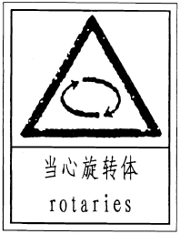
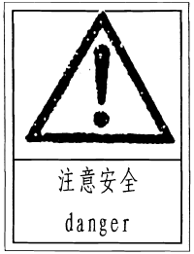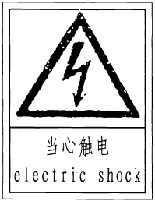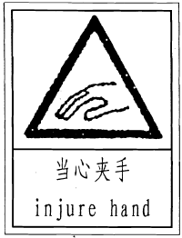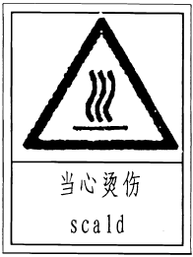

Unreadable and missing warning labels must be replaced immediately.
必须立即更换不可读和遗失的警告标识。
Don’t interpose any object witch could prevent the operator from seeing the labels.
不得有任何影响操作者观察这些标识的干扰。
Use the code in this clause to order labels that you might need.
建议使用本条款中的标识图样。

Chapter 2 Introduction of the machine第二章：设备介绍
- Application scope适用范围
MSZ30 is a bottle blowing machine which adopts injection blow molding technology to form a hollow container in one time. It can produce high grade bottle with high bottleneck precision. It is widely used in the manufacture package bottles in pharmacy, food, cosmetics, chemical and other trades.
本机为采用注射吹塑工艺一次成型中空容器的吹瓶机，能生产具有较高瓶颈精度的高档容器，广泛用于制造医药、食品、化妆品及化工等行业的包装用品瓶。
The machine is strictly prohibited to be used for processing other types of raw materials.
本机严禁用于加工其他类型原料。
- Structure of the machine机器结构
The structure of the machine as follow:
设备结构如下：

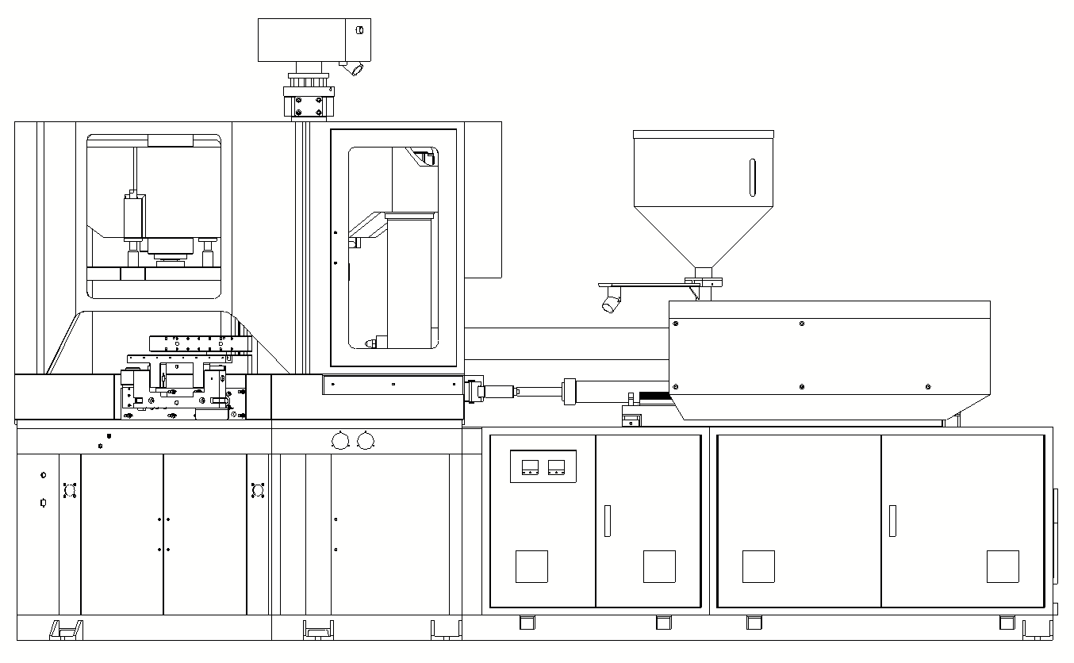

MSZ30

The machine is mainly composed of injection parts, injection mold closing parts, blow mold closing parts, rotary lifting parts, stripper parts, hydraulic control parts, electrical control parts, pneumatic control parts and conveying devices, etc. At the same time, it is necessary to purchase air compressor (including purification device), mold temperature controller, chiller and other accessories.
该机主要有注射部件、注塑合模部件、吹塑合模部件、回转升降部件、脱模部件、液压控制部件、电气控制部件、气路控制部分及输送装置等构成，同时必须购置空气压缩机（包括净化装置）、模温控制器、冷水机等配套件。
- Mechanical parts机械部分
- Frame机架
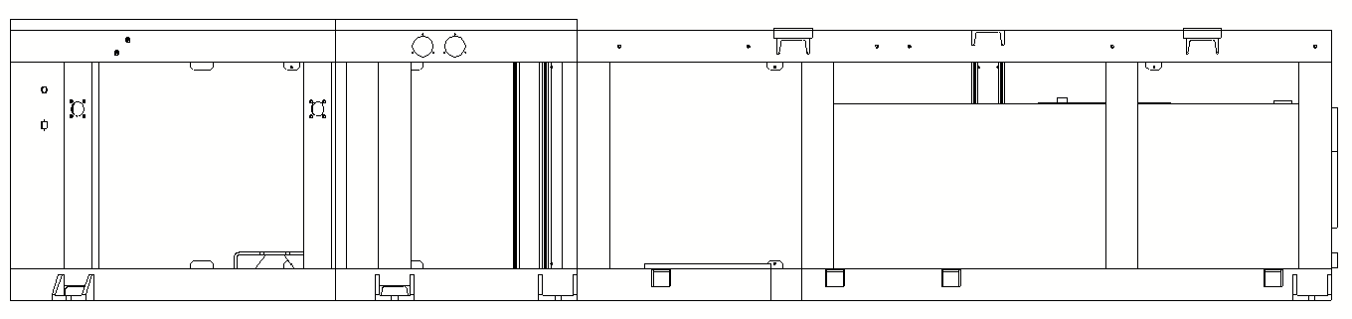

The frame adopts integral structure welded by profiles. The front side of the frame has a certain stiffness to ensure that it can withstand large clamping force without deformation. The upper plane of the rear side of the frame is fixed with a glue injection device. The lower part is a fuel tank, and the rear part of the fuel tank is equipped with an air filter. The lower part of the rear side has an oil drain hole (for cleaning the fuel tank). The upper part of the frame is equipped with a ejector, and the lower part is equipped with motors, oil pumps, etc. The intermediate space is pipelines, and the electrical control cabinet is located in the internal space in front of the frame.
机架采用型材焊接而成的整体式结构。机架前侧具有一定的刚度，确保承受大锁模力而不变形。机架后侧的上平面固定射胶装置，下部为油箱，油箱后部设有空气滤清器，后侧面下部有放油孔（清洗油箱用）。机架上面装有射台，机架下面有电机、油泵等，中间空间为管路，电气控制柜设在机架前面内部空间。

- Injection device注射装置
The injection device of the machine adopts double oil cylinder injection structure, the injection force is large and even, low speed and high torque hydraulic motor is used to drive the screw, the injection device consists of barrel, screw, hopper, jetting plastics, stroke control device, screw rotating device, injection nozzle moving cylinder and so on.Its specially designed screw enables the plastic to be uniformly melted into a molten state, and a quantitative amount of plastic can be injected into the mold cavity through the hot runner at a selected pressure and speed.The device has good melting glue, accurate measurement performance, through the proportion of pressure, flow can be adjusted to obtain the required pressure and speed, the implementation of multiple injection, in order to adapt to different types of resin and different products requirements.
机器的射胶装置采用双油缸射胶结构，射胶力大而均匀，采用低速大扭力液压马达驱动螺杆，射胶装置由机筒、螺杆、料斗、射胶、行程控制装置，螺杆转动装置，射嘴移动油缸等组成。其特殊设计的螺杆使塑胶均匀地熔化成熔融状态，并可以以选定的压力和速度将定量的塑胶通过热流道射入模腔内。本装置具有熔胶良好，计量精确的性能，通过比例压力，流量的调整可获得所需要的压力和速度，实行多次射胶，以适应不同树脂种类和不同制品的要求。
The barrel and screw of this device are made of high quality nitrided steel, which has a long service life after nitridation treatment, and the screw head has a reverse ring, which can reduce the backflow of materials along the screw during injection.
本装置的机筒和螺杆均采用优质氮化钢，经过氮化处理，使用寿命长，螺杆头部有止逆环，可减少注射时物料沿螺杆的回流。

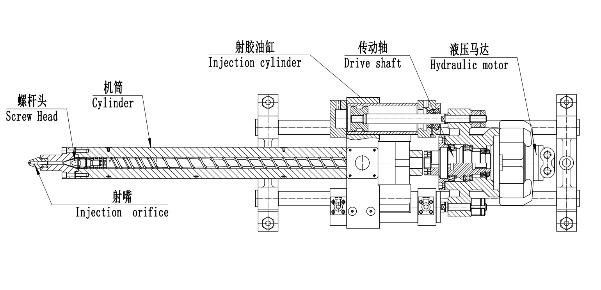

Notes for stroke calibration of injection cylinder:
If the machine works for a long time, it may cause the ejection piston rod to wear out, so it is necessary to replace the ejection piston rod. To prevent the two injection cylinders from being out of sync after replacement, relevant calibration shall be carried out.
- After the replacement of the ejector piston rod, inject it to the bottom under manual mode(the locking nut of the ejector piston rod is not installed)
- Put an adjusting washer on one end of each ejector rod.
- Move the ejector plate toward the head plate so that the second plate is in contact with one of the adjusting pads
- Measure the gap between another adjusting washer and the second plate and record the data
- Process one end of the adjusting washer in contact with the second plate according to the measured data, so that the installed two adjusting washers are in contact with the second plate at the same time
- Reinstall and tighten the nut
射胶油缸行程校准注意事项：
机器长时间工作后，可能会造成射胶活塞杆磨损，需更换射胶活塞杆。更换以后为防止两个射胶油缸不同步，需进行相关校准。
1.射胶活塞杆更换好以后，在手动状态下注射到底(未安装射胶活塞杆的锁紧螺母)
2.在每根射胶活塞杆的一端套上一个调整垫圈
3.将射胶二板向头板方向移动，使二板与其中一个调整垫接触
4.测出另一个调整垫圈与二板的间隙并记录数据
5.按测出的数据加工与二板接触的调整垫圈一端，使安装好的两个调整垫圈同时与二板接触
6.重新安装锁紧螺母

- Injection blow mold clamping device注吹合模装置
The injection mold clamping device is hydraulic direct pressure structure.It is mainly composed of oil tank of the booster(oil filling tank), lock-mold cylinder(plunger cylinder),mold clamp cylinder, moving form board, front and rear side plate,supporting plate(filling valve) and so on.
本机注塑合模装置属液压直压式结构，主要由冲液油箱，柱塞油缸，合模油缸、动模板、前后侧板、充液阀等组成。
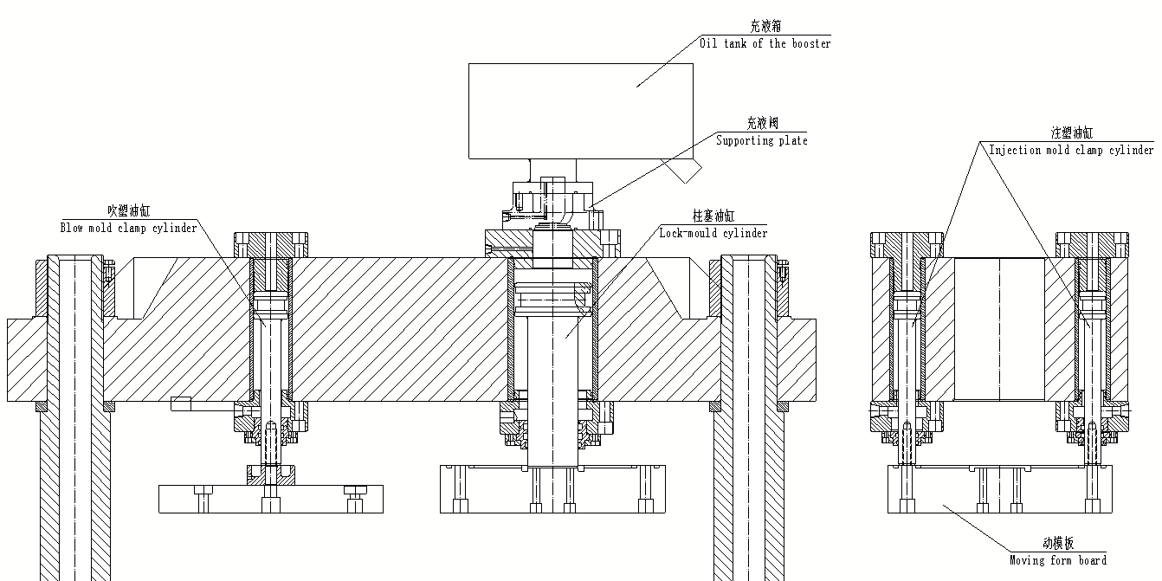

In order to improve productivity and reduce impact noise, a slow - fast - slow program is adopted.When mold slow opening or slow closing,the oil pump will supply oil at low pressure;When mold quick opening and quick closing, the oil pump will supply oil at high pressure, and the quick moving mold valve will work for differential filling oil.In this way, the purpose of energy saving and noise reduction can be achieved, and the temperature rise of hydraulic oil can be reduced.The position of the speed switch point is controlled by an electronic ruler and can be adjusted by the operator depending on the process.In order to meet the requirements of large clamping force of the injection mold, the injection mold closing device includes plunger cylinder, mold closing oil cylinder, liquid filling device and liquid filling tank. The advantages of adopting such a mechanism are as follows:The return oil of plunger oil cylinder is not supplied by the system, which can not only meet the requirements of high pressure clamping force, but also save the consumption of system pressure oil.And because the original supercharging cylinder is abandoned, it can better make up for the shortage of normal supercharging due to the leakage of sealing parts after a certain working time.In addition, it can also prevent the bottle preform flash caused by uneven clamping force.
The blow molding closing device is composed of a closing cylinder, a moving plate and a guide column. The mould closing cylinder is the same as the cylinder of the injection mold closing device.Ensure uniform force and smooth opening and closing by the guide column.
为提高生产率和减缓冲击噪声，移模速度采用慢—快—慢程序。慢开或慢合模时，油泵低压供油；快开及快合模时，油泵高压供油，并且快移模阀工作进行差动补油。这样可以达到即节能又能实现增速降噪的目的，并能减少液压油的温升。速度切换点的位置由电子尺控制，可由操作者视工艺情况调节。为满足注塑模大锁模力的要求，注塑合模装置有柱塞油缸、合模油缸、充液装置及冲液油箱，采用这样的机构的好处是：柱塞油缸的回油补油不经系统的供油，达到既能满足高压锁模力的要求，又节约了系统压力油的消耗，又由于舍弃了原有的增压缸故能较好地弥补了原油路经一定工作时间后因密封件泄漏变大而逐渐不能正常增压的不足。另外还兼具防止模板锁模力不均匀而使部分瓶坯出现飞边状况。
吹塑合模装置构成由合模油缸、动模板、导柱构成。合模油缸与注塑合模装置上合模油缸相同由导柱保证均匀受力和开合模平稳。
- Rotary device转位装置
The ratary device is mainly composed of rotary table,rotary base,core axle, rotary case, rotary cylinder,connecting base,index head, lifting cylinder and so on.The core rod is mounted horizontally on the rotary table,table drives the core rod do rotation of up - turn 120 ° - down.The injection, blow molding and demoulding processes are linked together.
转位装置主要由转塔，转塔座，芯轴，回转箱，回转油缸，连接座，拨叉，升降油缸等组成。模芯棒水平成直线安装在转塔互成规60°的三边上,转塔带动芯棒实行上升—转位于120°—下降的间隙回转运动,将注射、吹塑、脱模三个工艺过程有机地联系在一起。
Table lifting is completed by lifting cylinder.Table turning 120°is completed by the turn the indexing box.Rotation is completed by the rotary cylinder through the crank-link mechanism.The speed of each action can be adjusted by the throttle valve of the hydraulic system.The action switch is controlled by a signal from the proximity switch.Rotary table indexing positioning use indexing box to achieve coarse positioning firstly,then use positioning pin to achieve fine positioning.Positioning accurate, reliable, long life.
The dividing position of the turret is first set primarily by the dividing mechanism, and then the location pin fixes the precise position. The fixing position is accurate, reliable and use-life is long.
转塔升降由升降油缸完成，转塔回转120°由转位分度箱完成，回转运动是由回转油缸通过曲柄连杆机构来完成的，各动作速度可通过液压系统的节流阀来调节，动作切换由接近开关发信号控制。转塔分度定位先由转位分度箱实现粗定位，然后由定位销实现精定位，定位精确、可靠、寿命长。
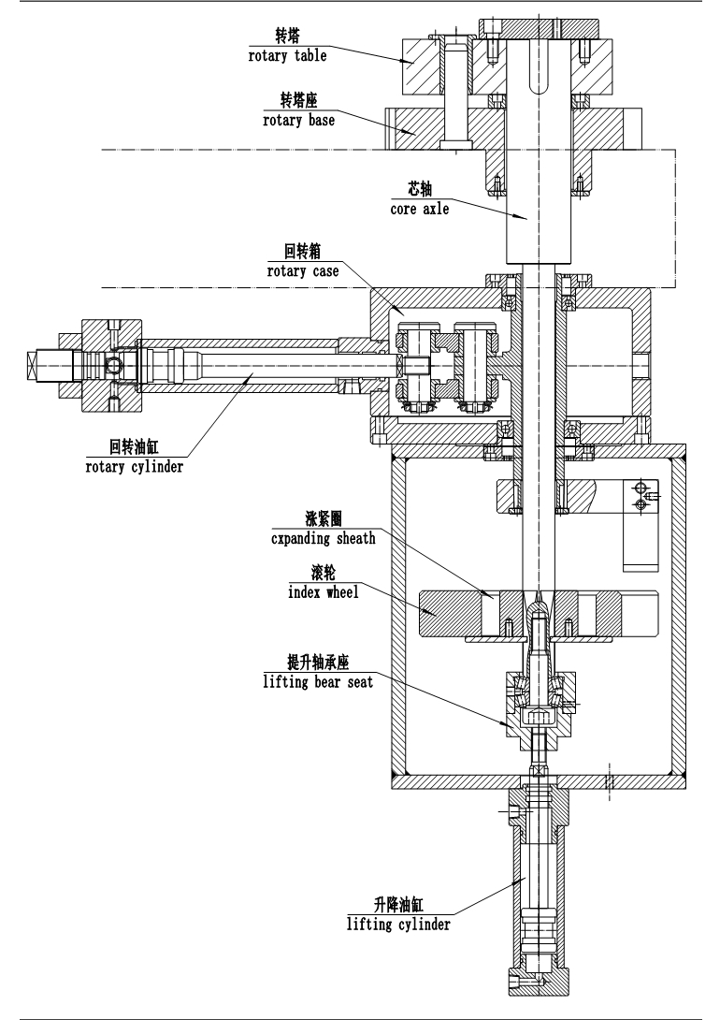

★★★Notes for 3 stations adjustment★★★
The machine may cause wear and tear or screw loosening after working for a long time.If the rotation of three stations cannot be positioned accurately, relevant adjustment should be made.
First, check the relevant parts of the rotary device to find out the cause
A．If it is caused by the loose hexagon socket screw on the index wheel
1）Operate the machine in a manual state and recommend professional maintenance. Any maintenance work must not damage the machine and the person, the movement must not have the mutual interference.
2）Lift the table in place
3）rotate the table in place.
4）Lower the table in place
5）Loosen the hexagon socket screws on the sheath of index wheel one by one evenly and symmetrically(M8）
6）rotate wheel place,make rotary wheel aim at fork,and make sure this two device nonintervention,move rotary table up and down 2-3 times,to make sure that two part coordinate.
7）Tighten the screws evenly and symmetrically one by one while lifting the turret in half stroke
8）check three station turn to the correct place.
B．If the problem caused by the rotary oil tank
1）check all the parts of turning tank loose or break
2）check piston rod connection and turning tank nut loose or not.
3）check piston and piston rod connection loose or not.
4）after tighten,please attention when install again.
5）Ensure the piston rod connecting the head and rotary box at the rotary push-plate connections with the initial position of box length tank
6）Rotary Cylinder stroke not do changes to ensure
★★★三工位调整注意事项★★★
机器在长时间工作后，可能会造成磨损或螺钉松动，造成三工位回转不能准确定位，则需要进行相关调整。
首先检查转位装置相关零件，找出故障原因。
A.故障原因确认是由滚轮上的内六角螺钉松动引起
1）在手动状态下操作机器，建议由专业人员维护。任何维护工作不得损坏机器和人，动作不得有相互干涉。
2）将转塔上升到位
3）将转塔回转到位
4）将转塔下降到位
5）逐个均匀对称地拧松滚轮帐套上面的内六角螺钉（M8）
6）旋转滚轮的位置，使滚轮开口对准拨叉，在拨叉和滚轮不干涉的情况下，将转塔上升下降2~3次，在转塔和三个定位导柱相互配合的情况下，使得拨叉和拨叉盘充分配合
7）将转塔升降在一半行程的情况下逐个均匀对称地拧紧滚轮帐套上面的内六角螺钉
8）检验确认三工位回转正确
B. 故障原因确认是由回转油缸或回转箱装配松动引起
1）检查回转箱内部零件有无松动或损坏
2）活塞杆连接头和回转箱连接处2内六角锁紧螺钉有无松动
3）活塞和活塞杆的连接有无松动
4）重新紧固后装配时注意
5）保证活塞杆连接头和回转箱推板连接配合处在回转箱长槽内的初始位置
6）保证回转油缸行程不做变更
- Stripping device脱模装置
The stripping device is mainly composed of stripping pushing plate, stripping cylinder, pushing bottle and others. It is fixed on the table. It mainly strip the shaped product out of the mould core bar and turn 90°and push bottles to make a group of bottles rank orderly on the conveying belt and are treated with flame. At the same time, it finishes the processes, such as inside cooling of core bar, outside cooling of core bar and others.
脱模装置主要由双脱模油缸，导柱，导套，脱模底板，转臂，脱模架，翻转气缸等部分组成，安装在台面板中间。它主要将已成型制品从模芯棒上脱出，翻转90°脱下，使一组制品整齐排列在输送带上，与此同时，还完成芯棒内冷，芯棒外冷等工序。
Exchange the stripping pushing plate and adjust the primary position to be suitable to different specifications of bottles.
更换脱模推板调节脱模推板初始位置，本装置就可适合不同规格的瓶子的脱模。
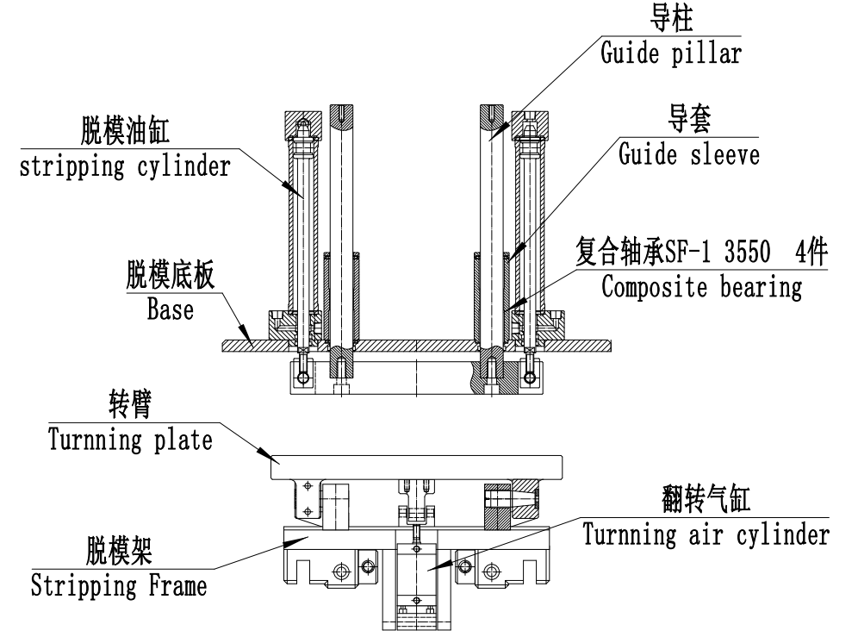
- Safe door安全门
A safe door is fixed on the table. It covers the clamping moulding device and the blow rotary device and others to prevent flying substance from entering the mould chamber to ensure normal production and operator’s safety.
在台面板的上面装有安全门，将合模装置、注吹回转装置等罩在里面，防止飞物进入模腔中，确保正常运转生产和人身安全。
Nitrogen spring is used to open and close the front door and proximity switch is installed in the front and rear safety doors to detect the closing situation of safety doors and protect personal safety. Please do not open the safety door at will, otherwise the machine will stop working.
前开门使用氮气弹簧开合，前后安全门装有接近开关，检测安全门关闭情况，保护人身安全。正常工作时请不要随意打开安全门，否则机器会停止运转。
Red emergency stop button and yellow emergency stop button are installed on the operating side of the equipment.Yellow emergency stop button is installed on the back of the device.After pressing the red emergency stop button, the equipment will power off.When the yellow emergency stop button is pressed, all the actions of the device will stop.
设备操作侧安装红色急停按钮和黄色急停按钮，设备背面安装黄色急停按钮，红色急停按钮按下后设备断电，黄色急停按钮按下后设备所有动作停止。

- Hydraulic system液压系统
- Oil pump- Sumitomo pump油泵-住友泵
This machine adopts servo pump with high performance and low noise. The system work pressure is 14MPa, the rated geometric discharge capacity is 32cm3/rev.Recommend use anti-wear hydraulic oil yb-n46.Foreign oil models refer to chapter 2.2.2.5.
本机采用高性能、低噪声的伺服泵，系统额定工作压力为14MPa（kgf/cm2），几何排量32cm3/rev。推荐使用抗磨液压油YB-N46. 国外油品型号参考2.2.2.5 章节。
- Valve block阀板
The hydraulic system has 3 oil circuit manifold,they are:
本机液压系统共有3个油路集成块，分别为：
a. Mold open and clamping valve block(Injection mold opening and closing, blow mold opening and closing, differential, pressure relief);
开合模阀板（注塑开合模，吹塑开合模，差动，卸压）

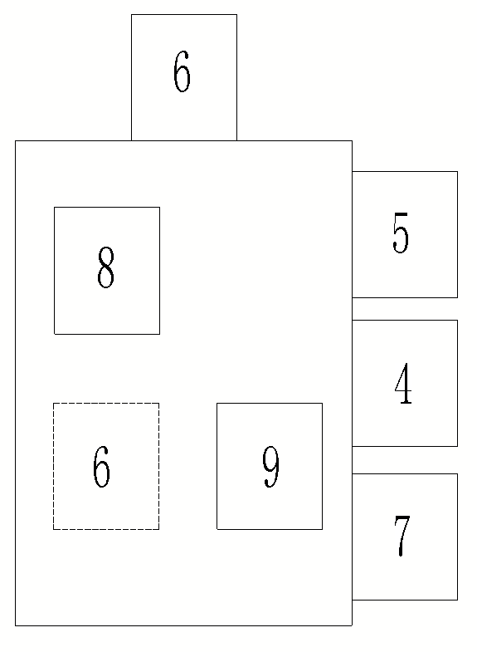

b. Injection valve block (injection,pre-plasticizing,suck-back);
注射阀板（注射，预塑，防涎）
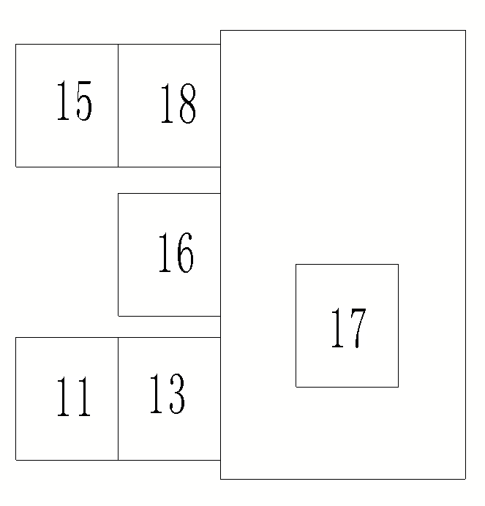

c. Auxiliary valve block (table rotary, table lifting, stripping).
辅助功能阀块（包括回转、升降、脱模）

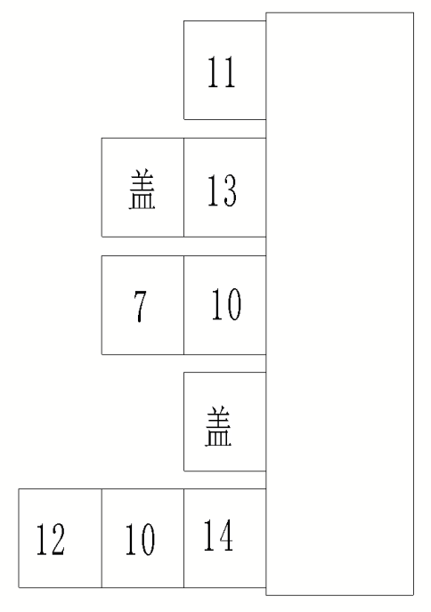

All the Valve No. on the layout please refers to: Chapter 8.3 Hydraulic parts list.
以上示意图上序号对应阀请参照附表：液压元件清单
- Filter过滤器
The oil suction filter is installed on the oil suction interface of the oil pump inside the oil tank.Clean it regularly according to the use of the machine and hydraulic oil pollution.
A removable cover plate is provided above the oil tank near the oil suction port for cleaning the oil suction filter.
吸油过滤器，安装在油箱内部油泵吸油接口上。视机器使用和液压油污染情况定期清洗
油箱上面接近吸油口处有一可拆卸盖板，用于吸油过滤器清洗。
When clean the filter,remove the filter from the cover plate,use gasoline or washing oil to remove dirt on blocking wire,use magnets to remove metal particles from the filter,then blow it clean with compressed air.
需要清洗过滤器时，从盖板处取出过滤器，用汽油或洗涤油彻底除去阻塞绕丝的所有杂物，用磁体吸附掉滤网上可能存在的金属微粒，然后用压缩空气将其吹净。
There are iron magnets under the oil suction port and the oil return port of the oil tank
油箱吸油口和回油口下方都放有吸铁石。
The air filter is mounted on the side of the tank to separate the tank from the outside air. The seal must be tightened, otherwise the oil will spill out.
空气滤清器安装与油箱侧面，用于分隔油箱和外部空气，其封盖必须拧紧，否则油液会溅出。
Attention:
A: When you take off the filter, can not start the motor and pump.
当你拆下过滤器时，请保证不会开启液压泵马达
B: If blocking wire break, please change the filter.
绕丝损坏时，请一定及时更换过滤器
C: After reinstalling the filter, please let the machine work without load for 5-10 minutes to ensure that the oil pump can work under load after working normally
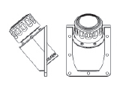
重新安装过滤器后，请让机器空载工作5-10分钟，确保油泵工作正常后可负载工作。

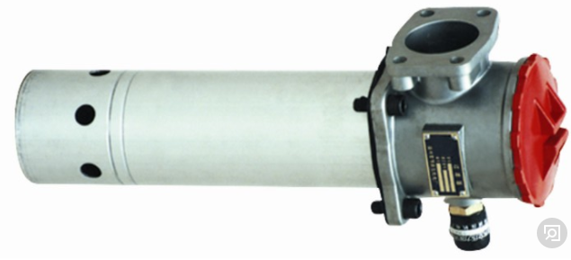

- Cooling system冷却系统
The part needs cooling on the machine: 本机需冷却的部分有：
1. Oil cooler for hydraulic system 液压系统油冷却器
2. Cooling for feeding port of the barrel 注射装置机筒加料口冷却
3. Mold temperature controller 模温控制器
4. Blow mold 吹塑模具
Among them, No.1&2&3 can use water from underground or cooling tower for cooling, water temperature no more than 28℃.
No.4 need chilled water,temperature around 15℃.
其中1、2、3项可用深井水或冷却塔出来的水循环冷却， 水温小于28℃；
4项用冷水机冷却， 水温约15℃。

Oil cooler drawing 油冷却器简图
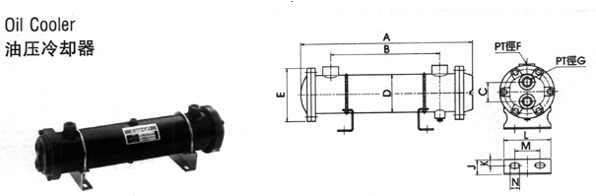

Water-cooled cooler mainly uses fresh water as the cooling medium, shell side fluid and pipe side fluid exchange heat through the heat pipe, so that the temperature of high-temperature oil drops, to achieve the purpose of cooling.
水冷式冷却器主要使用淡水作冷却介质，壳程流体与管程流体通过传热管交换热量，使高温油液温度下降，达到冷却的目的。
Note: release the fluid from the cooler if it may freeze after prolonged disuse or disuse
注意：在较长时间不使用或者停止使用后有可能产生冻结时，请将冷却器内的流体放出
If the cooling effect decreases, it may be caused by scaling inside the pipe. Please remove the end caps. Check for corrosion and impurities.
如果冷却效果下降，可能是管子内部结垢引起的。请拆下两端管帽。检查腐蚀和杂质的情况。
Depending on the local water quality, the oil cooler should be cleaned about once every six months.An alkaline cleaning solution commonly available in the market can be used to clean the inside of the main body and the outside of the heat conduction pipe.For the difficult to clean interlayer, use weak hydrochloric acid solution to clean the main body and conduction tube.If there is too much scale on the inner side of the heat transfer pipe, soak it with a cleaning agent that can dissolve scale, and then rinse it with a soft brush and clean water.
视当地水质情况大约每半年对油冷却器进行一次清洗，可采用市面上常见的碱性清洗液，清洗主体的内部和热传导管的外部。对于难清洗的夹层，可采用弱盐酸溶液清洗，冲洗主体与传导管。传热管内侧水垢较多时，请选用可溶解水垢的清洗剂浸泡，然后用软毛刷和清水冲洗干净。

Assembling drawing of oil cooler 油冷却器分解组装图
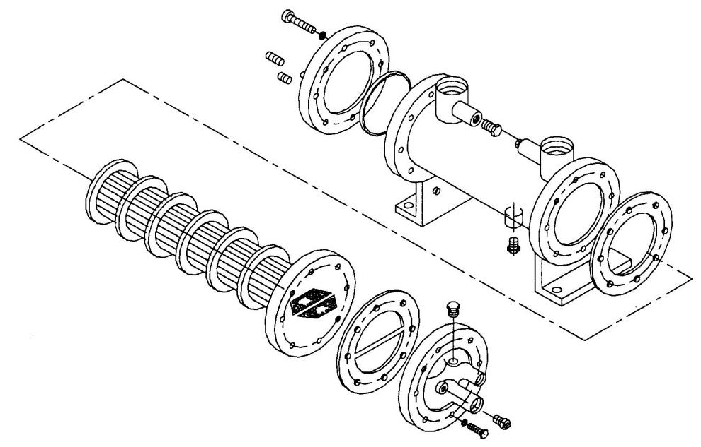

- Oil tank油箱
A．Clean of oil tank 油箱的清洗
Use the oil barrel hand pump or filter truck to pump the oil from the oil tank, screw the plug on the oil port, and completely empty the residual oil in the oil tank.At the same time pay attention to empty the old oil in the oil road, to ensure that the new oil is not contaminated after injection (residual oil will lead to accelerated aging of new oil).
使用油桶手摇泵或滤油车从住油口抽空油箱中的油，拧开放油口上堵头，将油箱内残油彻底排空。同时注意清空油路中的旧油，保证注入新油后不被污染（残油会导致新油加速老化）。
Open the oil tank side panel cover and carefully clean the oil tank inner wall to ensure that there are no impurities inside the oil tank. Clean the oil suction filter, plug the oil outlet, seal the side panel cover and inject new oil into the designated position.
打开油箱侧板盖，仔细清洗油箱内壁，保证油箱内部无任何杂质，清洗吸油滤油器，堵上放油口，封好侧板盖，注入新油到指定位置。
B．Hydraulic oil etc. 液压油等
This machine is recommended to use yb-n46 anti-wear hydraulic oil. After refueling, check the oil level of the oil tank to make the oil level higher than the intermediate scale of the oil level gauge. Generally, it is required to reach 75-80% of the oil tank volume.
本机推荐使用YB-N46抗磨液压油，加油后检查油箱油位，使油位高于油位计中间刻度，一般要求达到油箱容积的75%-80%。
Using Position | Oil Name | Introduced Oil Code | Remark
Oil tank | Wear-resistant hydraulic oil | China petro:YB-N46  Shell Tellus 46 or 68  Mobil: DTE25 or 26 | For India, Africa suggest 68  For Russia suggest 46  Moving viscosity at 50℃(Cat) 28-32
Moving section | Normal mechanical oil | 40# mechanical oil
Oil gun | grease | 00 | For injection unit
M.T.C | Heat transfer oil | Mobil: 605 or 603 | Boil 285 / 365℃

使用场合 | 名称 | 规格 | 备注
油箱 | 抗磨液压油 | 粘度68或46CST/40oC  美孚Mobil DTE26或25  壳派Shell Tellus Oil 68或46  嘉实多Castrol Hyspin ZZ 68或46  威斯达尔 68或46 号抗磨液压油  长城68或46号抗磨液压油 | 68号液压油适合当地气温较高时选用，温度适中和较低时建议选用46号抗磨液压油
运动部位 | 普通机械油 | 40#机械油
油枪 | 润滑脂 | 00 or 000 | 注射部件
模温机 | 导热油 | 美孚 605或603

- Accumulators蓄能器
Our accumulator type is NXQ1-L2.5/20-L-A, max work pressure: 20Mpa. Capacity:2.5L.The shell structure is small mouth
本机使用蓄能器NXQ1-L2.5/20-L-A 最大工作压力为20Mpa.公称容量2.5L，壳体结构为小口。
The working medium is hydraulic oil, and the connection mode is the capsule type energy storage with screw connection
工作介质为液压油，连接方式为螺纹连接的囊式蓄能
The oil is actually incompressible and therefore cannot store pressure energy.But bladder accumulator is adopting N2 gas which is compressible for store up some more hydraulic oil to reach this goal.
Accumulator is one important accessories for hydraulic system, which can store energy, stabilize pressure, eliminate pulsation, absorb shock and vibration, compensate volume and compensate leakage.
The capsule accumulator consists of an oil portion and a capsule with an airtight spacer (containing nitrogen).The oil located around the capsule communicates with the hydraulic circuit.So when pressure high,the oil goes into the accumulator then the N2 gas be compressed; when pressure decreased,the compressed gas expands,oil will go back to hydraulic circuit system.
油液实际是不可压缩的，因此不能蓄积压力能。胶囊式蓄能器是利用气体（氮气）的可压缩性来蓄积液体的原理（即采用氮气作为压缩介质）而工作的。
蓄能器是液压系统中重要的不可缺少的液压辅件。有储存能量、稳定压力、消除脉动、吸收冲击和振动、补偿容积和补偿泄漏等作用。
胶囊式蓄能器由油液部分和带有气密隔离件的胶囊（内装氮气）构成。位于胶囊周围的油液与液压回路相通。因此，当压力升高时油液进入囊式蓄能器由此气体被压缩；当压力下降时，压缩气体膨胀，进而将油液压入回路。

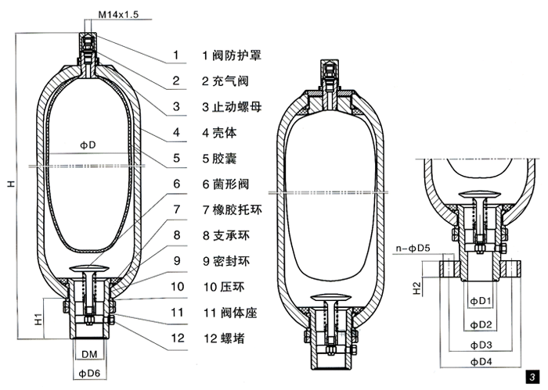

1.Valve safety cover 2.Air filling valve 3.Stop nut
4.Shell 5.Bladder body 6.Bacteria valve
7.Rubber ring 8.Support ring 9.Seal ring
10.Press ring 11.Valve seaf 12.Screll block.
The accumulator should use nitrogen, and need use special device for charging.
蓄能器要求冲装氮气，严禁使用其它气体，氮气的冲装需配合充气装置（选配件）
When charge, release the handle of over flow valve, open the cap of accumulator, connected the nitrogen with accumulator by charging device, open the switch slowly, when reach the 12MPa, it is finished. When the pressure is too high, unscrew the exhaust bolt to reduce the air pressure to the specified value.You need check the pressure of accumulator regularly.
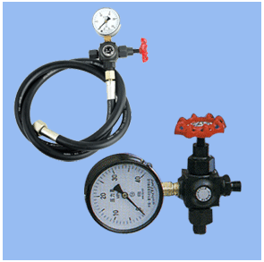
进行，充气时，松开溢流阀调节手柄，打开蓄能器上的盖帽，装上充气工具并和高压氮气连接，缓慢打开充气工具的开关，达到规定气压（12Mpa），当压力过高时，则拧开排气螺栓使气压降低到规定值。在使用过程中要求定期检查蓄能器气压，使气压保持在规定值。

The left is the charging device.
左图为蓄能器充气装置，需要时可以选购

Following is the drawing of charging.
下图蓄能器充气示意图
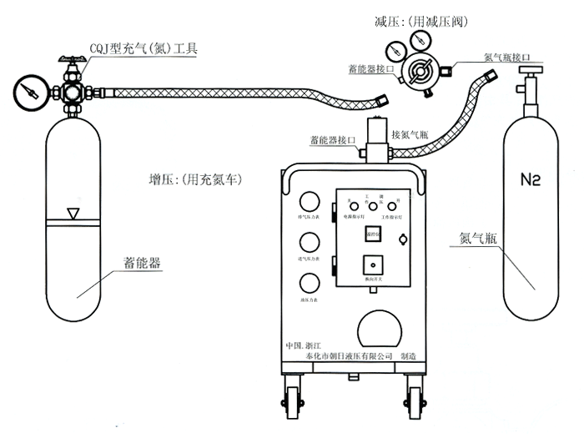

- Pneumatic system气动系统
Pneumatic system is used for the function of core rod out cooling, core rod in cooling, in cooling prepare, blow prepare, blow.
气路系统用以执行芯棒外冷、芯棒内冷、内冷预通、吹气预通、吹气等动作，各电磁换向阀均为无油润滑，确保卫生要求。
The pressure of compress air is 0.8-1.0Mpa.
气路系统用0.8-1.0Mpa高压气体定型吹塑满足吹塑成型工艺对压力流量的要求。
Capacity of compress air is 0.8 M3/Min.
压缩空气排量0.8立方米每分钟。

- Electrical system电气系统
The total installed power of MSZ30 is 25.6KW, the motor is 12KW(with servo pump), and the temperature control of the barrel heating has 4 zones for precision temperature control.Control system can choose two kinds, one is "servo" microcomputer control system (including touch screen); One is "omron" programmable controller, screen can choose "omron" or "kunlun" brand.The equipment is equipped with injection molding electronic ruler, which can realize the injection accuracy within the range of +/ -1mm.Open and close die using electronic ruler, on the one hand, open and close die speed is easier, more accurate, reflecting faster. The stripper also USES an electronic ruler, which makes it easier to adjust the cold position.Customers can achieve their own requirements as long as they touch.
MSZ30总装机功率25.6KW,电机使用12KW(配伺服泵），机筒加热有4个区的温控做精密温控； 控制系统可选择有两种，一种是“弘讯”微电脑控制系统（含触摸屏）， 一种是“欧姆龙”可编程控制器，屏幕可选用“欧姆龙”或“昆仑”品牌。设备上装有注塑电子尺,可实现注射精度在+/-1MM范围内,开合模均使用电子尺,一方面调开合模速度更容易,也更精确,反映速度更快,脱模也使用电子尺,这样调节外冷的位置更便捷。客户只要触摸就可实现自己的要求。
When there is foreign matter in the mold, the protection switch will send out a signal to stop the equipment.The device is also equipped with a stripping detection device. When the stripping is finished, if there is still bottle embryo on the core rod, there will be a signal for stripping detection, and the equipment will be stopped for processing.Whether it is equipment or personal safety, the equipment has done a careful treatment.
当模具内有异物时,保护开关发出信号,使设备停机. 该设备还装有脱模检测装置,当脱瓶结束后,如果还有瓶胚在芯棒上,则脱模检测有信号,设备做停机处理.无论是设备还是人身的安全,该设备都做了细致的处理。
Main features 主要特点
(1)High precision of bottle neck, bottle neck and thread can be achieved by hot runner system and high pressure injection molding.Products without seams and scrap materials, saving raw materials, at the same time with uniform specifications, appearance and so on.
采用热流道系统和高压注射成型，可获得较高的瓶口、瓶颈和螺纹精度。制品无接缝和边角料，节约原料，同时具有规格均一，外表光洁等特点。
(2)The machine adopts single screw horizontal injection mode for injection part and horizontal three-station rotary device for mold closing part, which can produce one mold and multiple cavities continuously with high efficiency.
该机注射部分采用单螺杆卧式注射方式，合模部分采用水平三工位回转装置，能一模多腔连续生产，效率高。
(3)High pressure clamping adopts accumulator to keep pressure, improve productivity and save energy.
高压锁模采用蓄能器保压，提高生产率，节省能源。
(4) The combination of demodulating automation and counting automation ensures that the products are free from contamination and meet the hygiene requirements of the food and medicine packaging industry
制品脱模自动化，计数自动化二者有机结合，确保制品不受污染，满足食品医药包装行业的卫生要求。
(5) In the mechanical, hydraulic, air control, electrical and many sets of adjustable links, to ensure that the process to meet the requirements of different products
在机械、液压、气控、电气上多处设有可调环节，以保证满足不同制品的工艺要求。
(6) It has strong applicability to raw materials, such as PE, PP, PVC and others.
原料适应性强，可成型大部分热塑性塑料。
(7)The machine adopts advanced, famous brand hydraulic electrical components.It has hand-operated, semi-auto and auto operation.
机器采用先进的、名牌液压电气元件，具备手动、半自动、自动操作。
(8) The production efficiency of the machine is high. Its noise is low and its power consumption is small, the operation is safe and convenient. It is an ideal equipment to produce package bottles for pharmacy, food and other trades.
该机生产效率高、噪音低、耗电量小、操作安全方便，是医药、食品等行业包装用品瓶的首先的理想机器。

- Nameplate铭牌
The nameplate is fixed on the surface of the machine, the template as follow:
铭牌固定在设备表面，示例见所示：

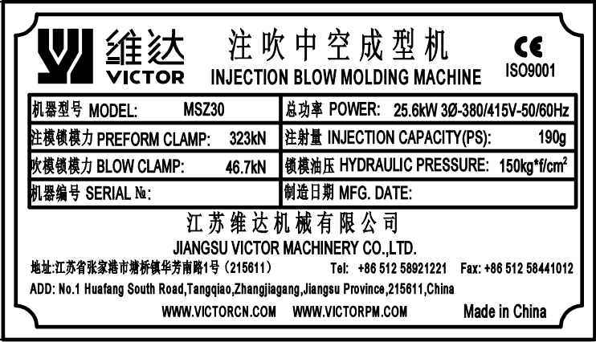

- Main technical parameter of the machine主要技术参数
Diameter of screw 螺杆直径 | 40mm
L/D of screw 螺杆长径比 | 23:1
Max. theory injection capacity 最大理论注射量 | 200cm²
Maximum injection capacity (HDPE) 最大注射量 | 190g
Hydraulic system pressure 液压系统压力 | 14MPa
Injection mold clamping force 注塑模合模力 | 289.7KN
Blow mold clamping force 吹塑模合模力 | 46.7KN
Mold opening stroke 开合模行程 | 120mm
Stripping stroke 脱模行程 | ≤ 220mm
Height of stripping frame 脱模架高度 | 1000mm
Height of table lifting 塔台提升高度 | 65mm
Dry cycle time 空循环时间 | 3s
Max. mold plate size (L×W) 最大模具平面尺寸（长×宽） | 400×270mm
Thickness of mold 模具厚度 | 180mm
Product forming size 可成形制品范围 | 15-800ml
Product forming height 可成形制品高度 | ≤200mm
Product forming diameter 可成形制品直径 | ≤100mm
Power supply 电压 | 3/N/PE~380/415V, 50/60Hz
Total power 总功率 | 25.6KW
Motor power 电机功率 | 12KW
Heating capacity of barrel 机筒加热总功率 | 9.6KW
Heating zone 电热控制区 | 3+N qty
Max. pressure of compress air 压缩空气最大工作压力 | 1MPa
Capacity of compress air 压缩空气排量 | ≥0.8m³/min
Capacity of cold water 冷却水用量 | 3m³/h
Effective volume of oil tank 油箱有效容积 | 380L
Machine size (L×W×H) 机器外形尺寸（长×宽×高） | 3560×1250×2200
Machine weight 机器重量 | 4T

- Environment使用环境
Operating Temperature  操作温度 | -20°C to +40°C
Storage Temperature  储存温度 | -25°C to +55°C,avoid direct exposure to direct sunlight or thermal radiation  -25°C to +55°C，避免直接暴露在阳光直射或热辐射下
Shipping Temperature  运输温度 | -25°C to +70°C,avoid direct exposure to direct sunlight or thermal radiation  -25°C to +70°C，避免直接暴露在阳光直射或热辐射下
Altitude海拔 | < 1000 meters
Humidity  湿度 | At 40 ° C the condensing temperature, maximum relative humidity of 85%在40°C非冷凝的温度下，最大为85%的相对温度
Atmosphere  环境 | Non-flammable, corrosive  无可易燃物、腐蚀性物质
Electromagnetic compatibility (EMC)  电磁兼容性 | The working environment where equipment is manufactured with conformity to Electromagnetic compatibility (EMC)  设备安装的工作环境符合电磁兼容性的要求
Ambient light照明 | >300LUX
Noise level噪声等级 | <80dB(A)

Chapter 3 Lifting、transport and store第三章：吊装、运输和储存
- Lifting吊装
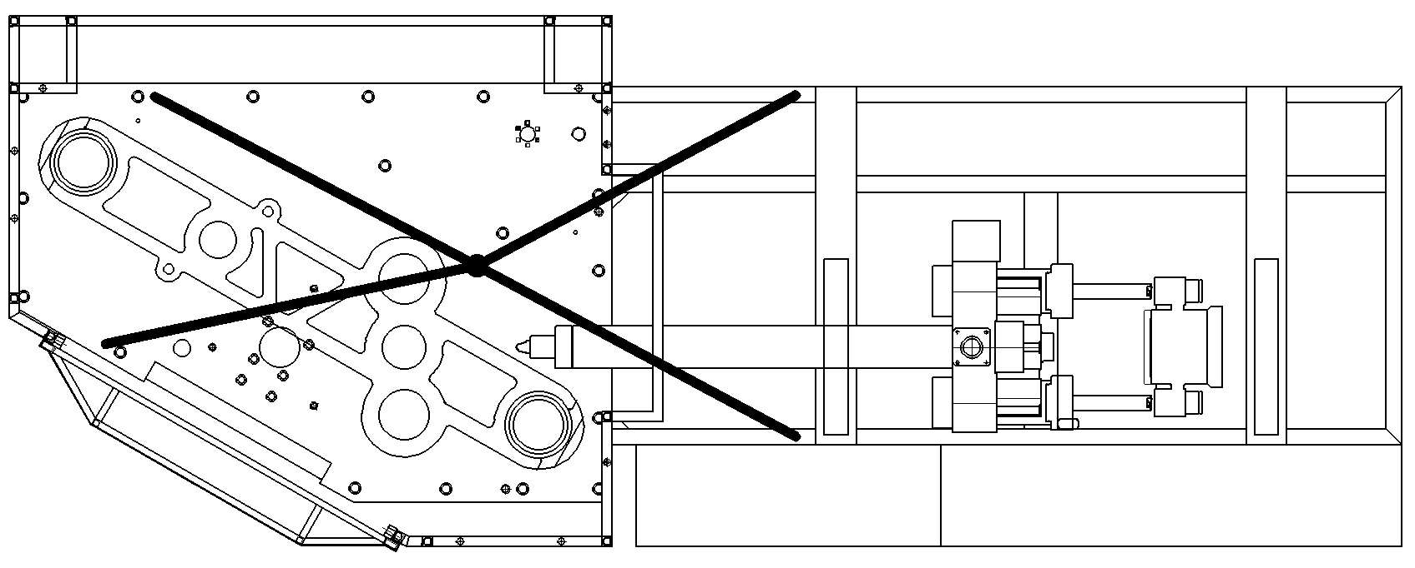

- The equipment shall be lifted by steel wires with enough strength and proper lift instrument (weight and size of machine, please refer to Chapter 2). Keep horizontality of loading strictly as moving with any kinds of lifting appliance;
应使用具备足够强度的钢丝绳或其他索具和适当的起重工具来提升设备。无论借助何种起重设备，均应在移动过程中严格保持载荷的水平度。
- Avoid damaging the parts during the unloading and handling operations, using straps tied around the machine. DO NOT PUSH OR DRAG ANY SECTION! The components are mechanical parts that have to be handled with care.
为了避免设备零部件在卸载和运输过程中的损坏，用带子捆扎在机器的周围，千万避免推或拖拉任何组件！这些组件都是机械产品，必须小心处理。

- Add the pad in the interface between the steel wire rope and the machine to prevent the appearance of the machine from damage.
在钢丝绳与机器接触之处应加衬垫，以防止机器外观受损。
- Avoid impact or strong vibration.
避免撞击或强烈振动。
- Try to lift the machine at normal speed more than 3 times. Lift it until you confirm that it is safe.
吊车在正常吊装速度下试吊三次以上，并确认安全可靠后，方可进行起吊操作。
During the equipment hoisting, the operator should give the signal to the helper at any time.
设备吊装过程中，操作者应随时对协助者给出信号提示。
- Store储存
Before sold, according to the requirements of environmental protection equipment should be placed in dry environment, the temperature in the 20 ° C ~ + 40 ° C, and avoid direct sunlight.
在售出之前，依照环境保护的要求，应将设备放置在干燥的环境中，温度在-20°C~+40°C之间，并避免阳光直射。
- Transport运输
The means of transportation used by the equipment include trucks, trains and ships. In the process of transportation, it must be noted that some goods indicated on the packing box cannot be superimposed must be placed on the top to prevent extrusion.
设备使用的交通工具包括卡车、火车、轮船。运输过程中必须注意有些在包装箱上表明了不能叠加的货物必须摆放在顶部，防止挤压。
- At the time of delivery, check whether the type and quantity of the products meet the requirements of the order confirmation before unloading
货物交付时，在卸货前检查产品的种类和数量是否符合订单确认书上的要求。
- If more than one machine is delivered, ensure that the same code is on the identification nameplate for different components of each machine
如果交货不只一台机器，确保每台机器的不同组件的辨认铭牌上具有相同代码。
- Keep the outer packing for reshipment
保留外包装以备再次运输。

Chapter 4 Installation第四章：安装
- Important！注意
- For the machine, the installation method has a significant impact on the function of the machine, the wrong installation will make the machine can not achieve the expected working ability, most of the fault is caused by incorrect installation.
对机器而言，安装方法对机器的功能有重大的影响，错误的安装将使得机器不能达到预期的工作能力，大多数的故障都是由于不正确的安装造成的。
- The installation and commissioning of the equipment can only be carried out under the guidance of employees of JIANGSU VICTOR MACHINERY CO.,LTD.
该设备的安装和调试只能在江苏维达机械有限公司雇员的指导下才能进行。
- The installation of the equipment must be carried out by well-trained and designated qualified professionals
该设备的安装必须由经过良好培训、指定的合格专业人员进行。
- All relevant safety regulations must be strictly observed.
这里必须严格遵守所有有关的安全规定。
- It is necessary to ensure that suitable power and other energy supplies are available at the installation site
必须保证在机器安装地点拥有适用的电源和其他能源供给。
- Ensure that the installation site meets the environmental requirements for use
确认安装地点满足使用的环境要求。
- Please refer to the manual for the instruction of the purchased equipment
外购设备的使用说明，见其说明书。
- Quality inspection of important components, such as electrical system, hydraulic system, etc., should be carried out before installation.
安装前，应对重要部件进行质量检查，如电气系统，液压系统等。
- Personal protective devices, such as work clothes, labor gloves, labor shoes and safety helmets, should be provided during installation
安装时应提供个人防护装置，如工作服、劳保手套、劳保鞋和安全头盔等。


- Working area requirements工作区域要求
- Working area ground should be level so that equipment can be placed smoothly
工作区地面应平整使得设备可以安放平稳。
- The site should be clean and tidy, free from inflammable, corrosive substances and dust.
场地应干净整洁，无可易燃物、腐蚀性物质以及灰尘。
- The user shall set a protective isolation belt at the working edge of the equipment
用户应在设备的工作边缘设置防护隔离带。
Attention!
Equipment shall not be used in potentially explosive environments
设备不得应用于潜在爆炸环境

- A free working range of at least 2m must be reserved at the front and back of the machine to ensure that personnel can access the machine at any time and without hindrance.
必须在机器的前后各保留至少2m的自由工作范围，以保证人员能够随时地、不受阻地接近机器。
- In the preparation of the foundation, should be arranged out of the pipeline channel, because the cable, water pipe, pipe, etc. to be laid under the ground.
在准备地基基础时，应安排出管道输送沟，因电缆、水管、气管等要铺设在地面下。
Do not enter this area without special training or authorization.未经过特殊培训和非授权人员严禁进入此区域！

- The main machine shall be fixed on the support surface with bolts to prevent loosening, moving or sliding caused by heavy materials during normal operation. All connection screws shall be tightened to a reliable level.
用螺栓将主机固定在支撑面上，防止正常操作时因较重材料产生的松动、移动或滑动，所有联接螺钉均应拧紧至可靠的程度。

- Installation安装
- Preparation准备工作
- Be familiar with installation technical requirements and drawing requirements before installation
安装前应熟悉安装技术要求和图纸要求。
- After the equipment arrives at the factory, all parts and components of the machine shall be inspected, counted and classified, and properly kept. It shall not be stacked in the open air to avoid corrosion and damage. If the organic parts are found to be incomplete or damaged, they shall be replaced
设备到厂后，应对机器各个零部件进行检查、清点、分类，妥善保管，不应露天堆放，以免锈蚀损坏，如发现有机件不全或损坏情况，应设法更换。
- Before installation, check whether the main parts of the machine are damaged. If they have been deformed, they should be adjusted immediately.
在安装前应检查机器的主要部件是否有损坏，如已经变形，应立即进行调整。
- Prepare necessary installation tools and materials.
准备好必要的安装工具和材料。
- Mechanical connection机械连接
The machine is normally put on the anti-vibration base. And then, the horizontal check must be carried out. Using the work table and the work layer of injection device as the base, adopt level to check the cross and longitudinal level of the machine. The levelness is 0.1/1000mm/mm.
机器一般应放置在避震垫上，之后应进行水平调整。可以利用机器的工作台面及注射装置的工作面作基准，用水平仪检查机器纵、横向的水平，水平度为0.1/1000mm/mm。
Adjustment of anti-vibration base
防震垫的调节
- Electrical connection电气连接
Connecting the machine to the power supply and any operation involving the junction box must be performed by a trained person.
将机器连接到电源以及任何涉及到接线盒的操作必须由经过专业训练的人员执行。
DISCONNECT THE POWER SUPPLY BEFORE CARRYING OUT ANY OPERATION! Before connecting the machine check that the voltage of the power supply corresponds with the voltage indicated on the identification plate on the machine. Always follow applicable safety regulations.
在进行任何操作之前断开电源！在连接机器之前，检查电源电压是否符合机器铭牌上指定的电压，务必要遵守适用的安全法则。
The wires of the machine adopts larger than 25mm2 copper wires. While jointing, joint the power cable with the terminal board in the electric control cabinet.
机器电源线采用大于25mm2铜芯导线。连接时，将电源线与电控柜中的电源连接板连接即可。
- Other connection其他连接
- Cooling water supply system冷却水供应系统
The pressure of cooling water system is 0.2~0.6MPa.
冷却水系统的供水压力为0.2~0.6MPa。
This machine has three places need cooling water:
本机器有三处需要冷却水。
- Oil cooler 液压冷却回路-油冷却器
- Cooling water for barrel unit 螺杆机筒冷却回路
- Cooling for blow mold 模具冷却回路
The cooling channel will be departed into 2 directions, one for oil chiller, another for water distributing block on the back side of the big table, which will go for cool the barrel and the mould.
冷却水分为2路，一路通油冷却器，一路通台面板后侧分水块，分水块分流后通机筒和模具。
Attention！注意事项
Cooling water must be clean, only fresh water as the medium, the user should regularly clean the oil cooler.
冷却水必须干净，只能用淡水作为介质，用户应定期清洗油冷却器。
Usually, the hydraulic oil temperature is not more than 55 ° C, oil cooler cooling water flow rate is more than 28 l/min..
通常情况下，液压油温度不超过55°C，油冷却器冷却水流速大于28L/min。
Hydraulic system:
1、When add hydraulic oil for the machine, please check the specification of the oil similar like YB46 made in China or DTE25 made by Mobil.
2、Be careful never make the oil touching your skin, you need have some protect devices when adding oil.
液压系统：
1、到现场加油，油品的参数见液压系统描述
2、注意防止液压油接触到皮肤，应佩戴个人防护装置等

Chapter 5 Operation第五章：操作
- Checking检查
Machine has been checked thoroughly prior to its shipment. However, for safety reason, please check the following items prior to the operation of the machine:
机器在出厂前已经进行了严格的检查，但出于安全的原因，请在正式使用前按照以下项目再次对机器进行检查。
- Make sure all protective devices are in good working order and no loose or damaged parts.
确认所有的保护装置出于良好工作状态，没有松动或损坏部件。
- Ensure that no foreign substances or water have penetrated inside the printer. Otherwise, remove the cover and clean out the printer. Subsequently re-close all openings.
确保没有外来物质或液体渗入机器内部，否则，打开封盖并清理机器，然后重新关上所有打开的地方。
- Check the voltage, phases and power source lead wires are correct as specified before connect the power to the machine.
在连接机器电源之前，检查电压，相位和电源引入线是否符合规定要求。
- Check whether all of buttons, operation handles, switches are damaged or not and make them be in “OFF” position.
检查各按钮、旋钮开关等有无损坏，并使各开关处于“断”位置。
- Check whether screws, oil pipes and limit switches are loose or not.
检查螺丝、油管及行程开关是否松动。
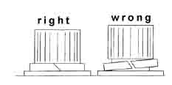
- Check the thermocouple
检查热电偶使用情况
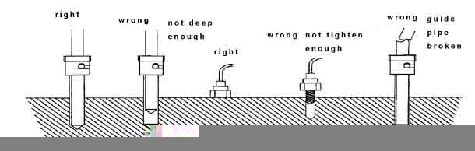
- Check the heating circle
检查加热圈使用情况
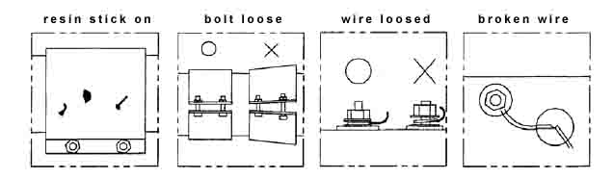
- All of lubricating sites must be lubricated.
各润滑部位按要求润滑。
- Screw off the cover of air filter, fill filtered hydraulic oil whose model is set, to the oil level, isn’t lower than 3/4 of the oil level. The work temperature of the hydraulic oil is normally 40~50°C, the lowest one can not be lower than 20°C, the highest one can not surpass 55°C. It must be exchanged regularly according to the rule.
油箱加油并检查油位。拧去空气滤清器上盖，注入规定牌号的经过过滤后的液压油，油加至油标指示的油位，不得低于油标尺的3/4处。液压油工作温度一般在40-50°C，最低不得低于20°C，最高不得超过55°C，液压油按规定定期换油。
- Check whether all of jointing is reliable and correct, particularly, notice the oil pump can not run anticlockwise.
检查各接线是否可靠正确，特别应注意油泵不能反转。
- Joint cooling water and gas pipeline, check whether all of pipe joints are leak or not.
接通冷却水及气源，检查各管接头是否有漏水、漏气现象。
- Preheat the cylinder, prevent the screw stem from starting in coolness.
预先加热机筒，避免螺杆冷启动。观察温度上升时间是否正常，确保加热圈，热电偶，接触器，保险丝，接线盒和配线的安全。
- Check whether there is foreign substance in hopper.
检查料斗内有无杂物。
- According to the technological demands, adjust the time relay, limit switch and temperature controller and set the pressure and flow of each section.
按工艺要求，调整时间值、限位开关位置及温度设置值，并设定各段压力流量。
- The entering gas source must be compressed air which is got ride of dust, water and oily fog. Its total containing content should be less than 10mg/m3, the dust content not more than 5μm, the air pressure is 1.2MPa, gas supplying more than 0.8m3/min. The gas source is solved by the consumers according to the demands. Combining the detail condition of the enterprise. The consumers also buy air compressor without oil, gas storing tank, air drier, filter and others. Refers to attached “Pneumatic Scheme”.
进入气路系统的气源应为除尘、除水、冷却、不含油雾的压缩空气，其总含量应小于10mg/m3，含尘粒不大于5μm，空气压力为1.2MPa，供气量大于等于0.8m3/min。气源由客户按上述要求，结合本单位具体情况自行解决，也可另行配置无油空压机，贮气罐，空气干燥器，过滤器等系统，见附图《气路系统原理图》。
- If everything works correctly, the test should be carried out. If troubles appear, stop the machine to repair immediately.
如果一切正常，进行第一次的测试，如发现问题应及时停车。
- Operation运行
If checking complete, the machine can be performed unloaded test-run.
检查完成后，即可进行无负载实验
Original records while operation must be taken. Meanwhile, check their conformity with design requirements.
运转时应做好原始记录，并查对和设计要求是否吻合
The first start-up test must be carried out with the machine empty. If everything works correctly, feed material into the machine and proceed normally. If troubles appear, stop the machine to repair immediately. After two hours test-run and satisfactorily accepted, the normal operation can be performed.
第一次的启动测试必须是在机器空载情况下进行，如果一切正常，才对带机器进料并继续正常工作，如发现问题应及时停车，当空载运转2小时并对运转情况满意后，可进行正常操作
Safety operation regulations must be established for normal operation. Damage and accidents caused by incorrect operation must be prevented.
为确保机器正常运行，为此必须制定安全操作规程，防止不正确的使用操作造成设备和人身事故。
During all operation, keep hands and other parts of the body as possible form moving parts of the machine!
在操作过程中，手部和身体其他部位尽可能的远离机器的运动部件！

- Unload test-run空转试运行
Caution: Before trial run without loading, the injection switch must be on “Off” position.
(1) Joint the power, start the motor and the oil pump, check the rotary direction of the motor is correct. The oil pump must run without loading for over 5 minutes. If the machine is started first or it is reused after it is stopped for a long time, the pump bearing must be turned over ten circles before the machine is started to make the inside of the oil pump lubricating.
接通电源，启动电机—油泵，检查电机旋转方向是否准确，油泵必须在空载情况下空运转5分钟以上。在机器首次启用或较长时间停机后再使用时应在开车前先用手转动泵轴十几转，使油泵内部得到充分润滑。
(2) Open the cut-off valve of cooling water to cool the returned oil to avoid the oil temperature too high.
打开冷却水截止阀，对回油进行冷却，以防油温过高。
(3) The pressure of hydraulic system is 14MPa. It is adjusted before the machine is carried out of the factory. The user need not adjust it. If it needs adjusting, please consult our factory.
液压系统压力15Mpa，出厂前已调整好，一般用户不需调整，如需调整须向本厂咨询。
(4) The allowable adjusting pressure and flow capacity are set with the external equipment.
允许调整的压力，流量均可设定。
(5) The trial run adopts manual operation method to check all of actions are normal.
用手动操作方式进行试车，检查各动作是否正常。
(6) When the machine is running, maybe the crawl condition or hitting sound will produce because there is air in the hydraulic system. After it runs for several times, the air in the oil circuit is exhausted, the above conditions will disappear. If it is not normal yet, the farther checking will need. After the trouble is removed, the machine will be tried run again.。
机器在运转时，可能会因液压系统中混有空气而产生爬行现象或撞击杂音，待运转动作数次或打开比例阀上的排气孔，油路中的空气排净后，爬行和杂音即会消失，若仍不正常，则须作进一步的检查，待排除故障后再重新试车。
- Load test run负载运行
1) Installing of mould 模具的安装
In the process of installing the mould, only manual operation method is permitted.
在模具安装过程中，只允许用手动操作方式。
When the mould is installed, pay specially attention to safety and protect the operators, machine and moulds. The operation steps as follow:
模具安装时，应特别注意安全，保护操作人员、机器及模具，可按以下步骤进行：
a) Press the button of manual operation to make the closing-mould device in opening state, the rotary tower lifts to the highest position, the injection unit backward to the final position. When it is necessary, the rotation is permitted.
操作手动按钮，使合模装置处于开启状态，转塔升至最高位置，注射座退至最后位置，必要时允许回转。
b) Clean the work table, mould coupling plate and mould, the outside surface of the upper and the lower mould frame with light oil and rag. On the touching section between the work table and the mould frame a little 30# mechanical oil is added and painted even.
用轻油、抹布清洗工作台面板、动模联接板及模具上下表面，在工作台面与模具相接触部位加少量30号机油，搽抹均匀。
c) The mould must be pushed into the work table horizontally. Forbid it falling into the work table. The mould is pushed into the positioning key. Notice that the mould is not hit with the barrel nozzle.
模具必须水平推入工作台面，切勿垂直落入工作台上。将模具水平推入定位键槽内，注意勿与喷嘴料筒相碰。
d) Make the mould move ahead to press tightly the adjustable washer.
使模具前移压紧前面的调整垫。
e) First fix the down mould on the machine table with the mold block, then champ mould (Note that the booster oil circuit cannot be connected. Fix the upper mould plate on the machine moving plate,then open mold).
先用螺钉压板将下模板紧固在工作台上，再操作合模动作（注意不能接通增压油路，将上模板紧固在动模联接板上，然后再开启合模装置）。
f) Check mould core pushing plate inside the rotary tower is smooth, then on a side of the rotary tower a group of mould core bar is fixed, turn the group of mould core bar to the injecting position, press the inching switch to make the rotary tower fall till the mould core bar bear the injecting mould. Watch the core bar is properly in the neck ring of injecting mould. If it is not suitable, loose the fixed screws of upper and lower mould to exchange the adjustable ring of the front end of the mould, finely adjust the mould position to make it match the core bar position. After it is fixed, tighten the upper and lower mould frames again.
检查模芯安装板内推板活动是否灵活，然后装上一组模芯棒，将该组模芯棒转到注塑工位，压下微点动开关，操作转塔下降微点动，使模芯棒下降至接近注塑模时停止，目测芯棒是否恰好卡入注塑模的颈环内，如不合适，则稍松开上下模紧固螺钉，更换模具前端的调整圈，微调模具位置，便之与芯棒位置相吻合，确保合适后，重新紧固上下模板。
g) Lift the rotary tower to turn the group of core bar to the blowing plastics work position. Adjust the blowing plastics position with the above method, at last fix the upper and the lower mould frames with screws.
将转塔升起，将该组芯棒转到吹塑工位，用上面的方法，调好吹塑模位置，最后用螺钉紧固上下模板。
h) Lift the rotary tower to make the group of core bar reach the stripping position, install the knockout plate. Adjust the knockout plate position with the above same method to make the core bar fall into the stripping plates properly, and then it is fixed with screws.
将转塔升起，使该组芯棒转达到脱模工位，装上脱推板，用上面相同的方法，调整脱模推板前后、左右的位置，使芯棒恰好卡入脱模板内，然后用螺钉紧固。
i) After the two moulds and the stripping device are fixed their positions, another two groups of mould core bar can be installed. First install the second group of core bar. Check if they are clamping correctly with the mould and the stripping. After the second one is checked, the third group of core bar is installed. It is also checked after it is installed.
当两个模具及脱模装置都定位正确后，便可安装另两组模芯棒。先安装第二组芯棒，检查一下是否能准确地与模具及脱模相吻合，第二组检查完毕，再安装第三组芯棒，同样也须进行检查。
j) According to the demands, joint the cooling water pipelines of mould, mould temperature control circuit, thermal heating pipes, install thermal coupling, check whether the water pipe and oil pipe and wires are touch the mould core bar. The joint wires must be safe.
按规定要求接好模具各冷却水管，模温控制管路，接好热流道加热管，装好热电偶，检查水管、油管电线是否会与模芯棒相碰，电线联接应确保安全。
k) Adjust the limit position of injection position to make the spray jet touch properly the thermal flow plate. Adjust the center of spray jet to aim at the center of the thermal flow each other to avoid leaking.
调节注射装置的喷嘴位置，使喷嘴刚好与热流道板刚好相接触，调整喷嘴中心与热流道中心互相对中，以防漏料。
2) According to the product characteristics and the technological demands, adjust the actions of various devices and the technological parameters.
根据产品特点和工艺要求，对各个机构的动作行程和工艺参数进行相应的调整。
a) Adjust the limit switch positions which need adjust.
调整需变动的限位开关位置。
b) According to the conditions of technology, adjust the technological time.
按工艺具体情况调定好各工艺时间。
c) Adjust the pressure and speed.
调整有关压力和速度。
d) According to the technological demands, adjust the set values of temperature controller. Notice that the charging barrel must be heated to the set temperature and keep it for some time (at least 15 minutes to ensure the material melt completely.) The pre-plasticizing action can be operated. (The charging barrel is heated, normally in the first section the temperature is higher, in the middle section, it is lower, and the last one near the discharging port is lower).
按工艺要求调整温度控制仪的设定值，切记料筒必须加热到规定温度并保温一定时间（至少15分钟，以保证物料充分熔融），才准操作预塑动作，（料筒加热，一般前段温度要高一些，中段稍低，靠近加料口听后段更低一些）。
3) When the machine is tried run primarily, it had better put polystyrene into the hopper. After the pre-plasticizing is normal, the plastics material which the product demands is fed into the filling port. The heating temperature must be adjusted according to different plastics.
初试时最好向加料口加聚苯乙烯料，待预塑正常后，再在加料口加制品要求的塑料，加热温度应根据不同塑料进行调整。
4) When it is tried run primarily, the spray jet is put away the mould and inject plastics outside the mould with hand. After it is normal, the injection inside the mould can be carried out.
初试时将喷嘴离开模具用手动操作进行模外注射，正常后再作模内注射。
5) After the mould core bar is preheated properly, the semi-auto operation is carried out. When the quality of the product is not satisfied, adjust the parameters properly till it can produce OK products. Then full-auto operation can be carried out.
对模芯棒进行适当的预热后，进行半自动操作时当制品质量不够满意时，适当调整工艺参数，至能正常生产出合格的制品后，可转入全自动操作。

- Manual operation操作
Refer to Electrical manual
参阅电气说明书

Chapter 6 Maintenance第六章：维修
Failure to follow the maintenances instructions may cause problems and could invalidate the warranty!
没有遵守维护说明可能使设备在使用中产生问题并且对此我们不做任何保证！
For your own safety, turn switch OFF, remove switch key and remove squeezing head from power source before maintaining or lubricating your machine!
出于对自身安全考虑，在任何维护或润滑机器之前必须关闭开关，移除开关钥匙和电源连接！
Only according to the provisions of institutionalized maintenance and maintenance, the machine can work smoothly and reliably, no or few failures. Wipe the obvious dirt from the machine every day, and clean it carefully regularly. Do not pile up any sundries in front of the operating parts and the electric control cabinet. Pay special attention to the damage of dust and particles to the electrical and hydraulic components and all moving parts.
只有按规定进行制度化的维护和保养，机器才能平稳可靠地正常工作，不出或少出故障。每天把机器上的明显污垢抹去，定期进行一次仔细的清洗，在各操作部位和电控柜前严禁堆放各种杂物，特别注意灰尘和颗粒对电气和液压元件及所有运动部件损害很大。
- Oil changing换油
During the normal operation of the machine for about 2000 hours, the hydraulic oil in the oil tank should be replaced for the first time, and the oil tank should be cleaned carefully during the replacement, and then the oil should be changed every time for about 6000 hours.
在机器正常运行2000小时左右，应第一次更换油箱中的液压油，更换时应对油箱仔细清洗，以后每次间隔6000小时左右换一次油。
Notice: the added oil must be the same kind of hydraulic oil. Don’t mix several oils together.
注：额外加油必须用同一种液压油，切勿几种液压油混用。
- Lubrication润滑
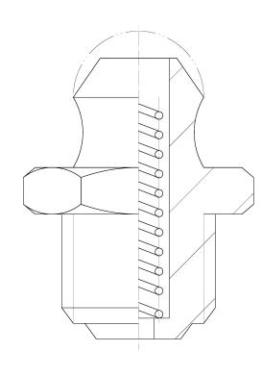
In order to ensure all of moving sections of the machine run normally, the lubricating points are fixed in all of main moving parts. Fill the lubricant or grease with an oil gun. Please lubricant and maintain according to the following:
为了保证机器各运动部件能长期正常运行，在主要运动的部件均设有润滑点，利用油枪，可以使润滑脂或润滑油注入运动部件，请按下列核定进行润滑和保养。

A. Grease filling holes: once every month.
润滑脂注入孔，每月润滑一次。
B. Before work of each shift, the moving sections of the machine must be lubricated.
每班操作前，机器的运动部位均应加润滑油。
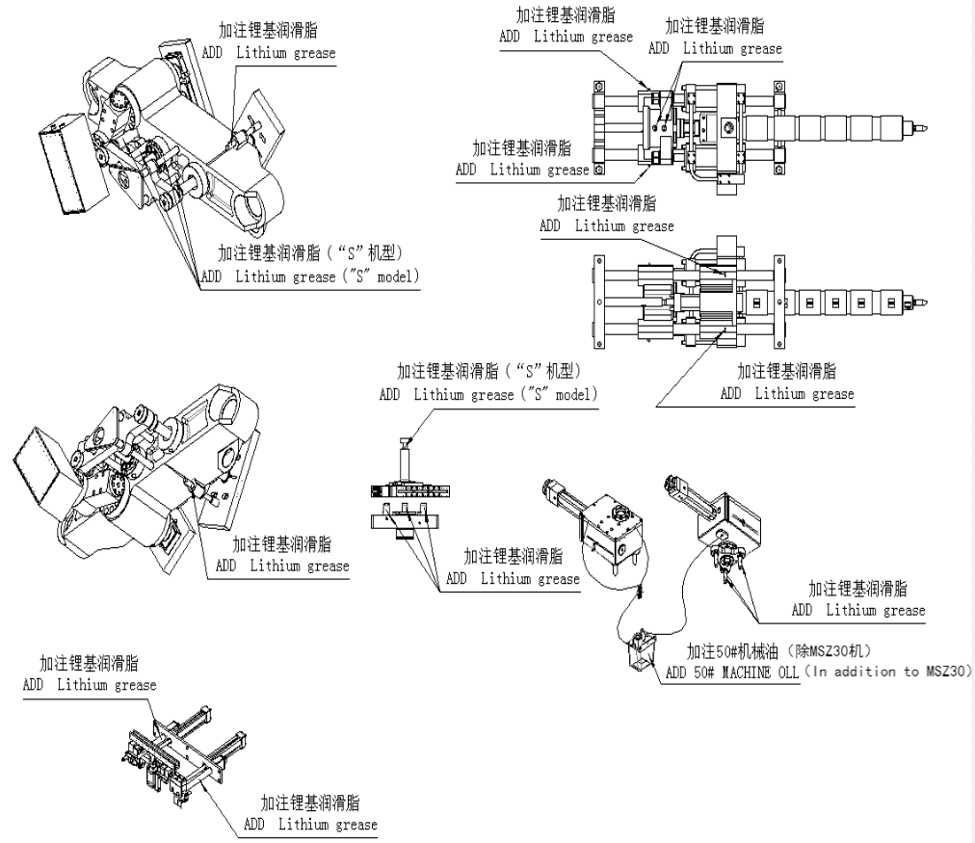

- Disassembling and cleaning cylinder and screw stem机筒、螺杆的拆卸和清洗
Before disassemble the screw stem, the filling port must be closed. The heat cylinder makes the remained material melted and injects it completely.
在装卸螺杆前应先关闭加料口，加热机筒使筒内的剩余胶料熔融，然后射尽机筒内熔化的胶料。
The process operation of disassembling the screw stem as follow:
拆卸螺杆的操作如下：
A. The screw stem rotates at low speed repeatedly to make the materials in the cylinder be injected completely.
螺杆推进到前端位置（推进至终端），可反复来回几次使机筒内物料被充分射尽。
B. The injecting device backs to the end;
射胶装置整体后退到终端。
C. Disassemble the hopper and heat ring, disassemble the nozzle.
拆除喷嘴部位的加热器，然后拧下喷嘴。
D. Loosen the joint screws of the injection table.
松开射台的有关连接螺钉。
E. While the material is in hot melted state, draw the screw stem out.
可在螺杆后端放一垫物，然后做射胶动作推出螺杆，注意要用低于10Kg/cm的射胶压力）。

- Other其他
Keep the machine cleaning, make maintenance regularly. Worn parts must be repaired or exchanged in time.
注意保持机器的清洁，定期维护保养，对已磨损的零件及时加以修复和更换。
Pay attention of moisture-proof or anti-heat of the electric control cabinet to ensure the machine runs normally.
电气控制柜应经常注意防潮防热，以保证正常工作。
Pay attention to supplying of cooling water to ensure the hydraulic temperature not surpass 50℃. Otherwise, the oil is easy to go bad and the airtight packing is easy to be damaged.
注意油冷却器的冷却水供应，确保液压温度不超过55℃否则油液容易变质，密封件容易损坏。
The oil cooler is washed once every 3-6 months.
油冷却器每隔3—6个月检查清洗一次。
The control cabinet must be cleaned timely ( normally 10 days)
控制柜内要定期清理（一般10天左右）。
The screws jointing the wires must be tightened timely ( normally 1 month);
导线连接螺钉要定期紧固（一般一个月左右）。
The sensors must be tightened to avoid moving (normally 1 month).
传感器要定期紧固，以防移动（一般一个月左右）。

Chapter 7 Troubleshooting第七章：故障排除
常见故障  Trouble | 故障原因  Cause | 排除方法  Removal
油温偏高  Oil temperature is too high | 油冷却器进水量小  Inlet volume of oil cooler is small. | 加大进水量  Enlarge the inlet volume
油缸内压力不足  Pressure in oil cylinder is not enough. | 密封件磨损、老化  The seal kit is worn and aged | 更换相应密封件  Exchange it.
制品不完整同时有溢料  The product is not complete and the material overflows. | 热流道口与喷嘴中心不同轴  Nozzle and runner gate not match | - 检查热流道口中心是否符合要求  Check whether hot runner gate meets the demand.  - 调整喷嘴球中心  adjust the nozzle jet center.
各运动部件在运动时不协调  The moving parts are not harmonious. | 各导向衬套拉毛或磨损  All of pilot shells are galled or worn. | - 更换相应的导向衬套  Exchange the pilot shells  - 运动部件加润滑油或润滑脂  Add lubricant or grease on the moving parts
熔胶困难  Melting plastics is difficult. | - 背压偏高  The back pressure is too high.  - 熔胶油压偏低  The oil pressure for melting plastics is lower. | - 按熔胶工艺调整背压  adjust the back pressure according to the melting technology.  - 调整预熔胶油压  adjust the oil pressure for pre-melting plastics.
油管接头处漏油  The oil joints leak. | 连接螺母松动  The jointing nut loosens. | 拧紧连接螺母  Screw tightly it.
阀板面出现渗漏  The valve plate leakage appears. | - 阀、法兰连螺母松动  The joint nut of valve, flange loosens.  - 密封件老化  The seal kit is aged. | - 拧紧连接螺母  screw tightly the nut.  - 更换密封件  exchange the seal kit
电磁铁动作失灵  Electromagnet action is out of order | - 灰尘的进入使咬死  - Dust entering  - 接线松动  - Wire joint loosens.  - 线圈损坏  The coil is damaged. | - 清洗电磁阀  Wash the electromagnetic valve.  - 接线拧紧保持接线良好  Tighten the wire joint.  - 更换线圈  Exchange the coil.
接近开关失灵  The limit switch is out of order. | - 固定螺钉松动接触不良  The fixed screws loosens and the contact is not good.  Spring or wiring loosens. | - 调整接触位置并固定  Adjust the contact position and fix it.  Exchange spring or tighten the wiring.
油泵噪音异常  The noise of the oil pump is unusual. | - 滤油器堵塞  The filter is blocked.  - 吸油管漏气  The oil absorbing pipe leaks.  - 液压油变质  The hydraulic oil becomes bad.  - 泵坏  The pump is bad. | - 清洗更换吸油滤油器  Wash and exchange oil filter.  - 拧紧吸油管喉箍  tighten the ring of oil absorbing pipe.  - 更换液压油  Exchange hydraulic oil.  - 换泵  exchange the pump.
油泵马达不能启动  The motor of oil pump can not start. | 自动开关跳闸  The auto switch trips. | 检查电源系统正常后合上自动开关  Check the power system. If OK, close it.
机筒温度过低  The cylinder temperature is too low | - 加热圈坏  - 自动开关跳闸  1.The heating ring is damaged  2. The auto switch trips. | - 更换加热圈  - 检查加热圈有无漏电后合上自动闸  1. Exchange heating ring  2. Check heat ring is electric leakage or not, close the auto valve.
机筒温度过高  The cylinder temperature is too high. | 固态继电器击穿，常通  Solid relay is damaged. | 更换固态继电器  Exchange it.

1 | Start automatically without action  自动启动无动作 | Check clamping position, turntable up position, forward and back position  检查开合模位置,转台上升位置,座进座退位置
2 | Pump can not be opened  油泵不能开启 | Check pump overload signal, and emergency stop signals, in manual mode  检查油泵过载信号,和急停信号,处于手动方式
3 | Can not open the mold  不能开模 | check the location of stripping back , turntable back position,suck back location  检查脱模返回位置,转台退回位置,防涎位置
4 | Can not close the mold  不能合模 | check the location of stripping back , turntable back position, mold protection signal  检查脱模返回位置,转台回转位置,模保信号
5 | Turntable can not rise  转台不能上升 | Check whether the manual valve is in the up position  检查手动阀是否处于上升位置
6 | Turntable not turning  转台不能回转 | Check mold injection mold blow mold position, and the turntable up position  检查注射模吹塑模开模位置,以及转台上升位置
7 | Turntable can not be returned  转台不能退回 | Check injection mold blow mold clamping position, and the turntable down position  检查检查注射模吹塑模合模位置,以及转台下降位置
8 | Stripping back show not in place  脱返显示不到位 | Stripping first then back  应先脱模然后再脱返
9 | Open mold show not in place  开模显示不到位 | Close mold first then open  应先合模然后再开模
10 | Can not be injected  不能注射 | Check if position injection 2 is smaller than position injection 1  检查注射2位置设的是否比注射1位置要小
11 | Can not be pre-plastic  不能预塑 | Check whether the deviation of the temperature range  检查温度是否在偏差范围内
12 | Can not prevent suck back  不能防涎 | Check whether the deviation of the temperature range  检查温度是否在偏差范围内
13 | PC output has signal, the valve does not work  PC输出有信号,阀不工作 | Check the circuit board 24V voltage is normal, not volatility. if volatility, replace the switching power supply test.  检查线路板上24V电压是否正常,不波动,若有波动,请更换开关电源试验.

Chapter 8 Attached figures&list第八章：附图附表
- Layout drawing of machine机器排布图
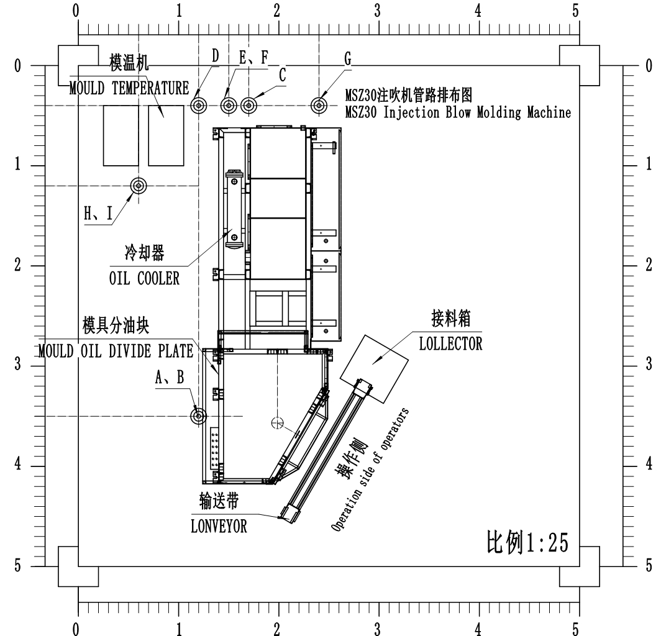

Explanation:
1.Pre-embed two main water pipes:
(1) cooling water (within 20℃), inlet caliber≥3'', keep 0.4Mpa.If over 80ml bottles are produced, cooling the mould is thought to adopt frozen water (about 10 ℃);
(2) The return pipe caliber of cooling water ≥3'', no back pressure.
2.Pre-embed one air main pipe, the caliber≥2''; supplying air pressure≥1Mpa, the air consumption of a set MSZ30 ≥0.8m3/min.
3.Each machine needs 2 sets of mould temperature controller. P=5KW/set, 10KW in all. Pre-embed AC 380V 3-phase power cable.
4.The power source for main machine of MSZ30 P=25.6KW/set,Pre-embed AC380 V 3-phase power cable，ground wire and network cable (recommended).
5. A port is the inlet of cooling water of mould, the caliber 1''. It is with cut-off valve;
B port is for the return cooling water of mould, caliber 1'';
C port is the outlet of compressed air, the cable 3/4'', with cut-off valve;
D port is the exit of the power cable of mould temperature;
E port is the inlet of cooling water for cooler of main machine; the caliber 1'', with cut-off valve;
F port is for the return cooling water of main machine, the caliber 1'';
G port is the exit of power cable of main machine;
H port is the inlet of cooling water for cooler of mould temperature, the caliber 1'', with the cut-off valve;
I port is the return cooling water of cooling water for cooler of mould temperature, the caliber 1''.
6. The net height of the factory building is 2.8m.The overall size of the machine is 3560x1250x2200mm. When the consumers are planning the detail position of the machine, please arrange the space positions between the machine and the factory building, between the machines according to your actual conditions. Besides, the water-power-air supplying specification and arrangement can be designed by yourself.

说明：
①．预埋主干道水管2根：(1)冷却水(20℃以内)进管管径≥3″，保持0.4Mpa压力，若成型80ml以上瓶，模具冷却应考虑用冷冻水(10℃左右)；(2)冷却水回水管管径≥3″，无背压。
②．预埋主干道气管1根：管径≥2″；供气压力≥1MPa，每台MSZ30机用气量≥0.8m3/min。
③．每台设备用模温机2台，P=5kW/台，共10kW，预埋～380V三相电源线。
④．每台MSZ30机主机用电源P=25.6kW/台，预埋～380V三相电源线，接地线机网线（建议）。
⑤、A口为模具冷却进水口，管径1″，带截止阀；B口为模具冷却回水口，管径1″；C口为压缩空气出口，管径3/4″，带截止阀；D、为模温机电源线出口（有机器航空插座提供）；E口为主机冷却器进水口，管径1″，带截止阀；F口为主机冷却器回水口，管径1″；G口为主机电源线出口；H口为模温机冷却器进水口，管径1″，带截止阀；I口为模温机冷却器回水口，管径1″。
⑥．厂房高2.8米以上。

- Hydraulic scheme液压原理图
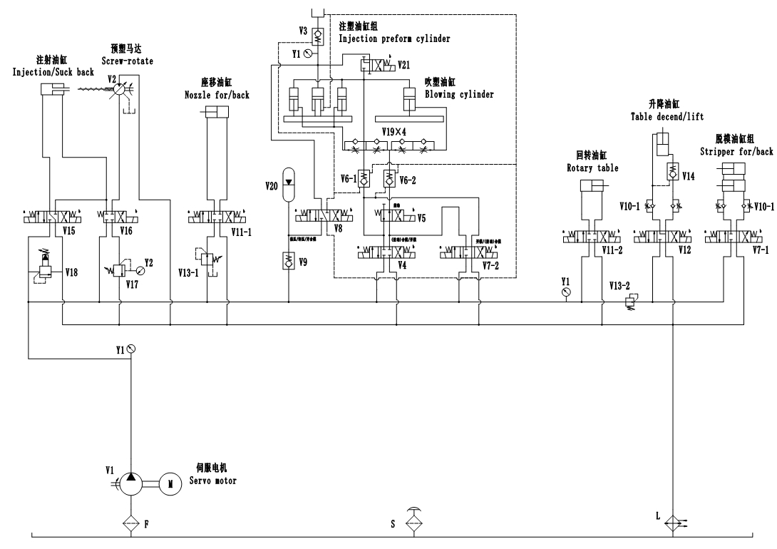

- Hydraulic part list液压元件清单
No序号 | Code  编码 | Name  名称 | Type  型号规格 | Brand  品牌 | Qty  数量 | Remark  备注
- 1 | V2 | 油马达  Hydraulic motor | NHM3-350 (B口进油) | 英特姆 | 1 | 预塑马达Screw-rotate
- 2 | V3 | 盘式充液阀  Re-fill valve | PDF-80-20 | 油研Yuken | 1 | 充液Refill
- 3 | V4 | 电磁换向阀  Directional valve | DSG-03-3C2-D24-50 | 油研Yuken | 1 | 开合模open&close
- 4 | V5 | 电磁换向阀  Directional valve | DSG-03-2B2-D24-50 | 油研Yuken | 1 | 合模差动close
- 5 | V6 | 液控单向阀  pilot controlled check valve | CPDG-06-E-04-50 | 油研Yuken | 2 | 开合模open&close
- 6 | V7 | 电磁换向阀Directional valve | DSG-01-3C10-D24-50 | 油研Yuken | 2 | 脱模、开合模stripping,open&close
- 7 | V8 | 电磁换向阀  Directional valve | DSG-01-3C12-D24-50 | 油研Yuken | 1 | 充液控制Refill
- 8 | V9 | 板式单向阀  One way valve | CRG-03-04-50 | 油研Yuken | 1 | 保压Increasing pressure
- 9 | V10 | 单向节流阀  One way throttle valve | MSW-01-X-30 | 油研Yuken | 2 | 升降、脱模lifting, stripping
- 10 | V11 | 电磁换向阀  Directional valve | DSG-01-3C2-D24-N1-51T203 | 油研Yuken | 2 | 回转、座移table rotat，Nozzle mov
- 11 | V12 | 电磁换向阀Directional valve | DSG-01-3C4-D24-50 | 油研Yuken | 1 | 升降  lifting
- 12 | V13 | 减压阀  Release valve | MRP-01-B-30 | 油研Yuken | 2 | 辅助、座移 release，Nozzle mov
- 13 | V14 | 液控单向阀  pilot controlled check valve | MPB-01-2-40 | 油研Yuken | 1 | 升降Refill
- 14 | V15 | 电磁换向阀  Directional valve | DSG-03-3C12-D24-50 | 油研Yuken | 1 | 射胶injection
- 15 | V16 | 电磁换向阀  Directional valve | DSG-03-2B2B-D24-50 | 油研Yuken | 1 | 预塑Screw-rotate
- 16 | V17 | 板式溢流阀  Relief Valve | BG-03-3231 | 油研Yuken | 1 | 预塑背压Screw-rotate pressure
- 17 | V18 | 板式溢流阀  Relief Valve | MBP-03-H-30 | 油研Yuken | 1 | 安全阀Relief valve
- 18 | V19 | 管式单向节流阀  One way holding valve | FT251/5-S-34-NPT | 进口 | 4 | 开合模调速open&close
- 19 | V20 | 蓄能器  Accumulator | NXQ1-L2.5/20-L-Y | 奉化 | 1 | 保压Increasing pressure
- 20 | V21 | 电磁换向阀  Directional valve | DSG-01-2B4B-D24-50 | 油研Yuken | 1 | 泄压  Pressure relief
- 21 | L | 油冷却器  Oil cooler | DT522 | 铁达 | 1 | 油液冷却Oil cooling
- 22 | F | 吸油过滤器  Oil filter | TF-160×100-LY | 涌镇 | 1
- 23 | S | 空气滤清器  Air filter | FSB.25.BM | 宁波 | 1 | 油箱斜口式加油口on the oil tank mouth
- 24 | Y1 | 油压压力表  Pressure meter | LB-250kg | 德玛斯dmass | 3 | 锁模、辅助Increasing pressure,release
- 25 | Y2 | 油压压力表  Pressure meter | LA-100 | 德玛斯dmass | 1 | 预塑背压Screw-rotate pressure
- 26 |  | 压力表线Pressure meter hose | HFK3-P3-3-P-2000 |  | 2

- Seal ring unit密封件清单
No  序号 | Name  名称 | Type  规格 | Qty数量 | Remark  备注
 | 组合密封圈Combined seal ring | DAS140-115 | 2 | 增压活塞杆lock-mould cylinder
 | 密封圈Seal ring | UHS90×105×9 | 2 | 增压铜套lock-mould cylinder
 | 防尘圈Anti dust seal | DH90×100×8/6 | 1 | 增压铜套lock-mould cylinder
 | “O”型圈ring | G115×3.1 | 1 | 增压铜套lock-mould cylinder
 | “O”型圈ring | G145×3.1 | 2 | 增压导向衬套lock-mould cylinder
 | “O”型圈ring | G135×3.1 | 2 | 增压上缸盖lock-mould cylinder
 | 组合密封圈Combined seal ring | DAS050-034 | 2 | 注塑活塞杆injection mold clamp cylinder
 | 密封圈Seal ring | UHS30×40×6 | 4 | 注塑铜套injection mold clamp cylinder
 | 防尘圈Anti dust seal | DH30×38×5/6.5 | 2 | 注塑铜套injection mold clamp cylinder
 | “O”型圈ring | G50×3.1 | 4 | 注塑铜套injection mold clamp cylinder
 | “O”型圈ring | G45×3.1 | 8 | 注塑导向衬套injection mold clamp cylinder
 | “O”型圈ring | G25×3.1 | 2 | 注塑法兰injection mold clamp cylinder
 | “O”型圈ring | G30×3.1 | 1 | 连接法兰injection mold clamp
 | 组合密封圈Combined seal ring | DAS063-047 | 1 | 吹塑活塞杆blow mold clamp cylinder
 | 密封圈Seal ring | UHS35×45×6 | 2 | 吹塑铜套blow mold clamp cylinder
 | 防尘圈Anti dust seal | DH35×43×5/6.5 | 1 | 吹塑铜套blow mold clamp cylinder
 | “O”型圈ring | G55×3.1 | 2 | 吹塑铜套blow mold clamp cylinder
 | “O”型圈ring | G55×3.1 | 4 | 吹塑导向衬套blow mold clamp cylinder
 | 防尘圈Anti dust seal | DH40×48×5/6.5 | 4 | 吹塑导柱盖板blow mold clamp cylinder
 | “O”型圈ring | G80×3.1 | 1 | 充液油箱oil tank of the booster
 | “O”型圈ring | G50×3.1 | 1 | 吸油过滤接头Oil filter
 | 骨架油封Skeleton oil seal | G50×70×10 | 1 | 上端盖rotary case
 | 骨架油封Skeleton oil seal | G550×80×10 | 1 | 下端盖rotary case
 | “O”型圈ring | G35×3.1 | 1 | 前缸盖Rotary cylinder
 | 密封圈Seal ring | UHS25×33×5 | 1 | 前缸盖Rotary cylinder
 | PTFE耐磨环 | FBS15×2.5-325 | 1 | 前缸盖Rotary cylinder
 | “O”型圈ring | G45×3.1 | 1 | 后缸盖Rotary cylinder
 | 组合密封圈Combined seal ring | DAS040-030 | 1 | 活塞杆Rotary cylinder
 | “O”型圈ring | P5×1.9 | 2 | 调节阀芯Rotary cylinder
 | “O”型圈ring | G25×3.1 | 2 | 调距螺栓Rotary cylinder
 | “O”型圈ring | G35×3.1 | 2 | 上、下缸盖lifting cylinder
 | 密封圈Seal ring | UHS20×28×5 | 1 | 上缸盖lifting cylinder
 | 防尘圈Anti dust seal | DH20×28×4.5/6 | 1 | 上缸盖lifting cylinder
 | 组合密封圈Combined seal ring | DAS040-030 | 1 | 活塞杆lifting cylinder
 | 防尘圈Anti dust seal | DH35×43×5/6.5 | 2 | 脱模底板stripping base
 | “O”型圈ring | G35×3.1 | 4 | 前、后法兰stripping cylinder
 | 密封圈Seal ring | UN18A×26×5 | 2 | 前法兰stripping cylinder
 | 防尘圈Anti dust seal | DH18×26×4.5/6 | 2 | 前法兰stripping cylinder
 | 组合密封圈Combined seal ring | DAS032-022/1 | 2 | 活塞杆stripping cylinder
 | “O”型圈ring | P9×1.9 | 8 | 减压阀盖Release valve
 | “O”型圈ring | P21×2.4 | 4 | 气路滑套Air slider
 | “O”型圈ring | Q114 | 4 | 气路滑套Air slider
 | 骨架油封Skeleton oil seal | G85×110×12 | 1 | 传动轴Drive shaft
 | 组合密封圈Combined seal ring | DAS090-070 | 2 | 射胶活塞Injection cylinder
 | “O”型圈ring | G30×3.1 | 2 | 射胶活塞杆Injection cylinder
 | “O”型圈ring | G55×3.1 | 2 | 密封铜套Injection cylinder
 | “O”型圈ring | G60×3.1 | 2 | 密封铜套Injection cylinder
 | 密封圈Seal ring | UHS35×45×6 | 4 | 密封铜套Injection cylinder
 | 防尘圈Anti dust seal | DH35×43×5/6.5 | 2 | 密封铜套Injection cylinder
 | “O”型圈ring | G85×3.1 | 4 | 射胶缸盖Injection cylinder
 | “O”型圈ring | P22×2.4 | 6 | 射胶法兰Injection cylinder
 | 组合密封圈Combined seal ring | DAS070-058 | 1 | 射移活塞Nozzle move cylinder
 | 密封圈Seal ring | UHS35×45×6 | 1 | 射移前缸盖Nozzle move cylinder
 | 防尘圈Anti dust seal | DH35×43×5/6.5 | 1 | 射移前缸盖Nozzle move cylinder
 | “O”型圈ring | G65×3.1 | 2 | 射移缸盖Nozzle move cylinder
 | “O”型圈ring | P21×2.4 | 6 | 气缸活塞Air piston
 | “O”型圈ring | P16×2.4 | 6 | 模芯安装板Core holder
 | “O”型圈ring | G25×3.1 | 6 | 模芯安装板Core holder
 | “O”型圈ring | P11×2.4 | 6 | 气缸活塞Air piston
 | “O”型圈ring | G25×3.1 | 1 | 出油口法兰Oil tank flange

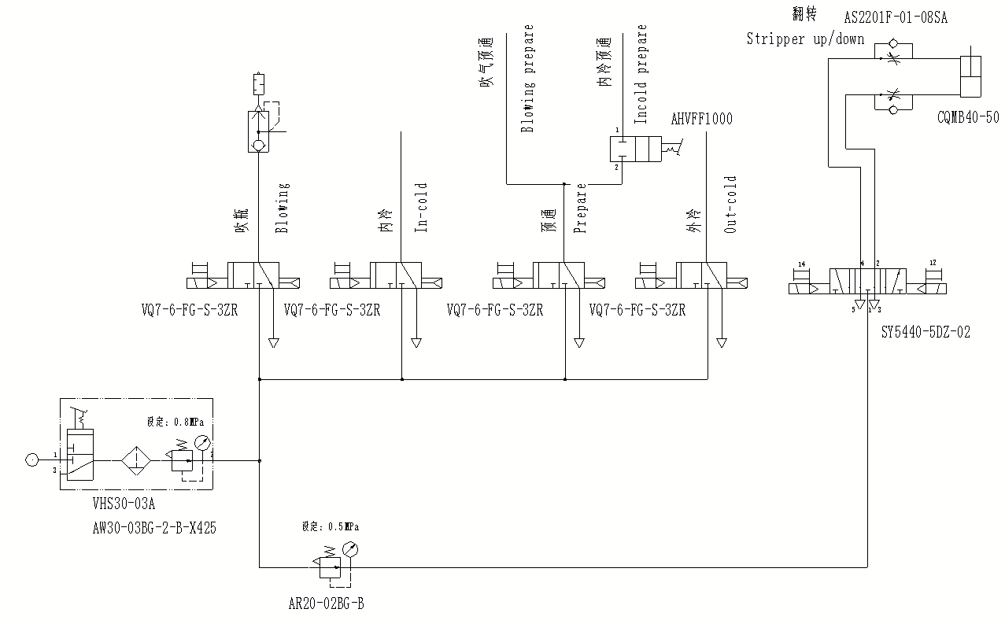
- Pneumatic scheme气动原理图

- Pneumatic part list气动元件清单
序号 | 名称 | 型号 | 数量 | 用途 | 产地
 | 开关阀Switch valve | VHS30-03A | 1 | 气源开关  air in switch | SMC
 | 模块连接件  Module connector | Y300T-A | 1 | 气源开关  air in switch | SMC
 | 手动阀Switch valve | AHVFF1000 | 1 | 内冷预通  In Cold Prepare
 | 过滤减压阀  Release valve | AW30-03BG-2-B-X425 | 1 | 减压  Release | SMC
 | 减压阀Release valve | AR20-02BG-B | 1 | 翻转  stripping | SMC
 | 电磁阀  Directional valve | VQ7-6-FG-S-3ZR | 4 | 吹瓶/内冷  Blow/In Cold | SMC
 | 电磁阀  Directional valve | SY5440-5DZD-02 | 1 | 翻转  stripping | SMC
 | 标准底座  Valve plate | VV714-02L-03B | 1 | 吹瓶/内冷  Blow/In Cold | SMC
 | 堵头  Plug | PLUG1/4 | 4 | 标准底座  Valve plate | SMC
 | 气缸  Air cylinder | CQMB40-50 | 1 | 翻转  stripping | SMC
 | 快速排气阀  exhaust valve | VSC-544-1/4-09 | 1 | 吹瓶  Blow
 | 消声器  silencer | AN20-02 | 1 | 吹瓶  Blow | SMC
 | 消声器  silencer | AN30-03 | 2 | 标准底座  Valve plate | SMC
 | 单向节流阀One-way throttle valve | AS2201F-01-08SA | 2 | 翻转气缸Turning cylinder | SMC

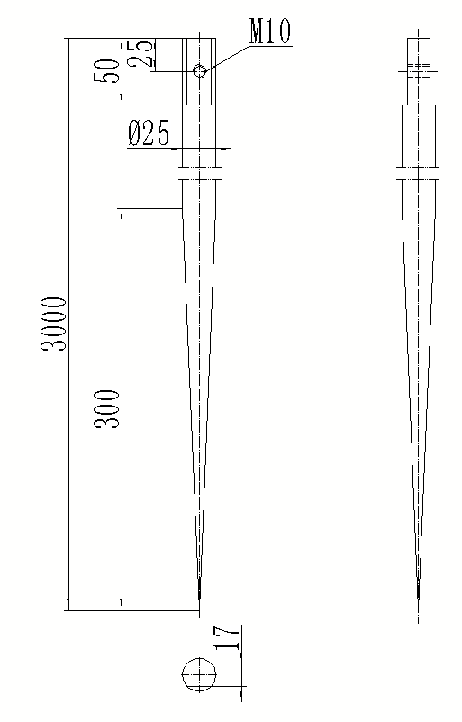
- Grounding Precautions接地注意事项
1. The grounding metal rod is made of red copper. The diameter shown in the figure is the minimum reference diameter.
接地金属棒材质为紫铜，图示直径为最小参考直径，直径更大接地效果越好。
2. The grounding wire must be PVC unsheathed copper core wire with a cross-sectional area of no less than 25mm square. It is led from the grounding end in the equipment servo drive to the grounding end of the frame, and then from the grounding end of the frame to the M10 screw as shown in the figure above. All joints are wound with waterproof tape or butter (vaseline) corrosion resistant treatment; The grounding point should be close to the device.
接地线必须为聚氯乙烯无护套铜芯线，截面积不得小于25平方毫米，从设备伺服驱动器内的接地端引出至机架接地端，再从机架接地端引出到上图所示M10螺钉，所有结点均采用铜拉鼻紧固连接，接地线尽可能短，所有连接处用防水胶布缠绕或黄油(凡士林)防腐蚀处理；接地地点选择为离设备近的好。
3. The water pipe and air pipe of the equipment shall not be hard connected by metal pipe, and the equipment shall not share the grounding wire with other equipment, and a separate grounding that meets the above requirements must be done. The grounding must be checked before the equipment is powered on.
设备的水管和气管不得采用金属管进行硬联接， 并且本设备不能与其他设备共用接地线,必须做符合以上要求的单独接地，设备通电之前必须检查接地，如未做好接地，严禁开机。
4. The grounding resistance is less than 10 ohms.
接地电阻<10Ω。

- Equipment troubleshooting manual设备故障解决手册

售后故障解决手册-设备
序号 | 产品问题点 | 解决方法及步骤 | 备注
1 | 设备注射不稳定（时飞边时缺口） | 1.检查各方面压力是否稳定
1 | 设备注射不稳定（时飞边时缺口） | 2.更换注射电子尺
1 | 设备注射不稳定（时飞边时缺口） | 3.更换螺杆头
1 | 设备注射不稳定（时飞边时缺口） | 4.更换机筒螺杆
2 | 驱动器异常 | 1.检查驱动器编码器是否松动
2 | 驱动器异常 | 2.重新调整驱动器参数
2 | 驱动器异常 | 3.更换驱动器
3 | 预塑速度慢 | 1.检查各方面压力是否稳定
3 | 预塑速度慢 | 2.更换油马达
4 | 产品黄斑，黑气，黑点 | 1.排除是否使用回料
4 | 产品黄斑，黑气，黑点 | 2.清洗机筒螺杆
4 | 产品黄斑，黑气，黑点 | 3.更换路罐头
4 | 产品黄斑，黑气，黑点 | 4.更换机筒螺杆
5 | 充液阀PDF-90损坏 | 1.出厂前检查阀芯螺丝是否松动
5 | 充液阀PDF-90损坏 | 2.调整至合适的参数
5 | 充液阀PDF-90损坏 | 3.更换充液阀型号
6 | 预塑速度慢，预塑时系统压力低 | 1.检查油马达是否泄漏，更换油马达
6 | 预塑速度慢，预塑时系统压力低 | 2.更换预塑电磁阀
6 | 预塑速度慢，预塑时系统压力低 | 3.更换螺杆
6 | 预塑速度慢，预塑时系统压力低 | 4.更换油泵
7 | 产品中间2个黑气 | 1.更换螺杆头
7 | 产品中间2个黑气 | 2.更换色母
8 | 开合模时声音较大 | 1.调节开合模调速阀流量
8 | 开合模时声音较大 | 2.更换新的调速阀
9 | 增压压力低 | 1.检查蓄能器气压是否正常
9 | 增压压力低 | 2.检查充液阀
9 | 增压压力低 | 3.更换安全溢流阀
10 | 设备一直预塑 | 1.检查预塑阀是否卡死
10 | 设备一直预塑 | 2.更换放大板输入输出点
11 | 翻转复位时撞到芯棒 | 1.调整脱模返回的的电子尺位置，先翻转复位后再脱模返回
12 | 产品塑化不好，有花纹（30机) | 1.更换金逸图纸的机筒螺杆
13 | 转塔漏气，产品不成型 | 1.检查气管是否松动
13 | 转塔漏气，产品不成型 | 2.检查转塔内小活塞上O形圈是否磨损
13 | 转塔漏气，产品不成型 | 3.更换转塔
14 | 设备报警停机 | 1.调整驱动器参数时发现未装刹车电阻
15 | 设备无增压 | 1.检查各参数是否正常
15 | 设备无增压 | 2.检查蓄能器压力
15 | 设备无增压 | 3.检查充液阀
16 | 增压压力保持不住，产品飞边严重 | 1.检查蓄能器压力
16 | 增压压力保持不住，产品飞边严重 | 2.检查充液阀
16 | 增压压力保持不住，产品飞边严重 | 3.检查压力传感器
17 | 伺服电机超温报警 | 1.检查伺服参数
17 | 伺服电机超温报警 | 2.改变电机接线方式
18 | 产品两边2个黄线 | 1.清洗热流道
18 | 产品两边2个黄线 | 2.更换卡式螺杆头
19 | 退回不到位 | 1.调整接近开关位置
19 | 退回不到位 | 2.放松回转后缸盖螺母
19 | 退回不到位 | 3.重新调整好位置好固定回转活塞杆前面的紧定螺丝
20 | 设备不能脱模，脱模返回 | 1.检查输入输出信号
20 | 设备不能脱模，脱模返回 | 2.检查电磁阀
20 | 设备不能脱模，脱模返回 | 3.检查电子尺固定螺丝是否松动
21 | 开模时有卡顿（50S） | 1.检查开模电磁阀阀芯是否有异物卡住
21 | 开模时有卡顿（50S） | 2.检查同步连杆是否弯曲变形
21 | 开模时有卡顿（50S） | 3.同步导柱加润滑油
22 | 电脑控制面板的指示灯时亮时不亮 | 1.检查通讯连接线是否松动
22 | 电脑控制面板的指示灯时亮时不亮 | 2.更换电脑板
23 | 设备不能开模 | 1.检查输入输出信号
23 | 设备不能开模 | 2.更换电磁阀
23 | 设备不能开模 | 3.检查接线盒内部线路
24 | 产品成型后开模时爆瓶 | 1.确认是一个工位还是三个工位
24 | 产品成型后开模时爆瓶 | 2.检查模芯安装板内小活塞上的O形圈是否磨损
24 | 产品成型后开模时爆瓶 | 3.更换快速排气阀
24 | 产品成型后开模时爆瓶 | 4.调整气压
25 | 产品注模时就有飞边（三付模具） | 1.检查增压压力是否正常
25 | 产品注模时就有飞边（三付模具） | 2.增加增压时间
25 | 产品注模时就有飞边（三付模具） | 3.调整合模到位的电子尺参数
25 | 产品注模时就有飞边（三付模具） | 4.减小背压
26 | 加温不正常（一段持续升温，一段加不上） | 1.检查热电偶
26 | 加温不正常（一段持续升温，一段加不上） | 2.更换固态快
26 | 加温不正常（一段持续升温，一段加不上） | 3.更换加热圈
26 | 加温不正常（一段持续升温，一段加不上） | 4.更换接线盒内部加热小主板
26 | 加温不正常（一段持续升温，一段加不上） | 5.发现机筒堵头未装好漏水，造成短路
27 | 充液小油箱喷油，注模开模慢 | 1.增加开模前的泄压时间
27 | 充液小油箱喷油，注模开模慢 | 2.更换泄压阀，充液阀
27 | 充液小油箱喷油，注模开模慢 | 3.检查蓄能器气压并更换蓄能器

- Electric scheme电气原理图

- Daily maintenance日常保养事项

Chapter 9 Special configuration instructions第九章：特殊配置说明

